**Things I Like Doing**

Please place a check mark in the box next to each activity you like to do. At the bottom of the page, you may want to write in other activities you enjoy doing.

|  |  |  |  |
| --- | --- | --- | --- |
|  | Taking part in sports |  | Playing a musical instrument |
|  | Hiking |  | Making pottery |
|  | Skiing |  | Researching information |
|  | Bowling |  | Jewelry-making |
|  | Exercising |  | Caring for pets and animals |
|  | Skateboarding |  | Fixing cars |
|  | Jogging |  | Photography |
|  | Track events |  | Building things |
|  | Ice-skating |  | Reading books |
|  | Aerobics |  | Reading magazines |
|  | Watching sports |  | Helping older people |
|  | Dancing |  | Going to movies |
|  | Drawing |  | Traveling |
|  | Painting |  | Sewing |
|  | Gardening |  | Singing |
|  | Cooking |  | Puzzles |
|  | Listening to music |  | Playing video games |
|  | Building models |  | Designing computer games |
|  | Working on a mystery quiz or a  crossword puzzle |  | Collecting things (circle)  rocks stamps cards other: \_\_\_\_\_\_ |
|  |  |  |  |
|  |  |  |  |

**About Me**

Please write in your honest responses on the lines.

|  |  |
| --- | --- |
| I like to… |  |
| I brag about… |  |
| I worry over… |  |
| I feel hurt when… |  |
| I make believe that… |  |
| I feel sorry when… |  |
| I’m afraid that… |  |
| When I read, I… |  |
| I feel proud when… |  |
| I feel ashamed when… |  |
| I hate to… |  |
| I am disgusted with… |  |
| I am happy when… |  |
| I get angry when… |  |
| Most books are… |  |
| Some teachers are… |  |
| Some kids are… |  |

**Interest Inventory**

Please fill in the blanks with your most honest answers.

1. When you have extra time to spend as you please, what do you like to do?

1. What games do you like to play?

1. What things have you made?

4. What kinds of tools or play things do you use?

5. What do you collect?

6. What are your hobbies?

7. If you could have one wish which might come true, what would it be?

8. What is your favorite TV program?

9. Which movie have you liked best?

10. What is the best book you have ever read?

11. What kind of books do you like best?

12. Have you read books or stories about the kind of work you want to do when you finish school? Name them:

**Interest Inventory**

13. Have you seen anyone on television or in the movies who does the kind of work you want to do?

14. What school subject do you like best?

15. What school subject do you like least?



**Who Am I?**

What are you all about? Answer the questions below to help you find out.

1. What do you like to do with your spare time?

2. Where would you like to go on a vacation?

3. If you could change your name, what would it be?

4. What is your favorite movie?

5. What is your best strength or talent?

6. What movie do you like seeing over and over again?

7. If you could have a pet, what pet would it be?

8. What famous person would you like to meet?

9. Of what possessions are you most proud?

Now, choose one of the ideas above and tell more about your feelings in the space provided below.

**My Interests Review**

1. I liked these things when I was little:

I like these things now:

2. I was interested in these things when I was little:

I am interested in these things now:

3. I wanted to be these things when I was little:

I want to be these things now:

4. When I grow up, I might want to be:

**When I Grow Up**

**\_\_\_\_\_\_\_\_\_\_\_\_\_\_\_\_\_\_\_\_\_\_\_\_\_\_\_\_\_\_\_\_\_\_\_\_\_\_\_**

**- - - - - - - - - - - - - - - - - - - - - - - - - - - - - - - - -**

**\_\_\_\_\_\_\_\_\_\_\_\_\_\_\_\_\_\_\_\_\_\_\_\_\_\_\_\_\_\_\_\_\_\_\_\_\_\_\_**

**\_\_\_\_\_\_\_\_\_\_\_\_\_\_\_\_\_\_\_\_\_\_\_\_\_\_\_\_\_\_\_\_\_\_\_\_\_\_\_**

**- - - - - - - - - - - - - - - - - - - - - - - - - - - - - - - - - \_\_\_\_\_\_\_\_\_\_\_\_\_\_\_\_\_\_\_\_\_\_\_\_\_\_\_\_\_\_\_\_\_\_\_\_\_\_\_**

**\_\_\_\_\_\_\_\_\_\_\_\_\_\_\_\_\_\_\_\_\_\_\_\_\_\_\_\_\_\_\_\_\_\_\_\_\_\_\_**

**- - - - - - - - - - - - - - - - - - - - - - - - - - - - - - - - - \_\_\_\_\_\_\_\_\_\_\_\_\_\_\_\_\_\_\_\_\_\_\_\_\_\_\_\_\_\_\_\_\_\_\_\_\_\_\_**

**\_\_\_\_\_\_\_\_\_\_\_\_\_\_\_\_\_\_\_\_\_\_\_\_\_\_\_\_\_\_\_\_\_\_\_\_\_\_\_**

**- - - - - - - - - - - - - - - - - - - - - - - - - - - - - - - - -**

**\_\_\_\_\_\_\_\_\_\_\_\_\_\_\_\_\_\_\_\_\_\_\_\_\_\_\_\_\_\_\_\_\_\_\_\_\_\_\_**

**\_\_\_\_\_\_\_\_\_\_\_\_\_\_\_\_\_\_\_\_\_\_\_\_\_\_\_\_\_\_\_\_\_\_\_\_\_\_\_**

**- - - - - - - - - - - - - - - - - - - - - - - - - - - - - - - - - \_\_\_\_\_\_\_\_\_\_\_\_\_\_\_\_\_\_\_\_\_\_\_\_\_\_\_\_\_\_\_\_\_\_\_\_\_\_\_**

**\_\_\_\_\_\_\_\_\_\_\_\_\_\_\_\_\_\_\_\_\_\_\_\_\_\_\_\_\_\_\_\_\_\_\_\_\_\_\_**

**- - - - - - - - - - - - - - - - - - - - - - - - - - - - - - - - -**

**What’s My Preference?**

Please place a check mark next to the choice that describes you. *Only choose one item from each row.*

|  |  |  |  |
| --- | --- | --- | --- |
|  | Work indoors |  | Work outdoors |
|  | Work alone |  | Work with other people |
|  | Work with your hands |  | Work with your mind |
|  | Work in the daytime |  | Work at night |
|  | Work for a boss |  | Be a boss yourself |
|  | Create or build something |  | Use plans someone else has made |
|  | Work in a city |  | Work in the country |
|  | Make a lot of money at a job you don’t like |  | Enjoy your job |
|  | Have a job you can get when you finish high school |  | Have a job that requires college |
|  | Have a job where you travel |  | Have a job where you stay in one place |
|  | Work in your home |  | Work outside your home |
|  | Be famous |  | Be known only by your family and friends |
|  | Have a job where you help other people |  | Have a job where you work with machines, papers, and other things |

Look carefully at the choices you have made. Think of three jobs you might one day have that would interest you most.

1.

2.

3.

**What Kind of Career Will I Prefer?**

These questions will be helpful in understanding what jobs you might like or perform best. Please place a checkmark the best response for each question.

|  |  |  |
| --- | --- | --- |
| Do you prefer (like) to work alone or with others? | Alone | With others |
| Would you rather have a job requiring a lot of walking and standing or one which would allow you to sit? | Stand/Walk | Sit |
| Do you prefer a job where you might get dirty or one where you may stay neat and clean? | Dirty | Neat and clean |
| Do you keep calm when you have several tasks to do at one time, or do you work best when there is only one task to do at a time? | Several | One at a time |
| Do you prefer to try new task, or do the same tasks? | New | Same |
| Do you prefer to work with tools or numbers? | Tools | Numbers |
| Do you enjoy doing a task or telling others how they should do it? | Doing it | Telling others |
| Do you prefer to work regular hours or hours that change? | Regular | Change |
| Do you prefer to work outdoors or indoors? | Outdoors | Indoors |
| Do you prefer to work the day shift or night shift? | Day shift | Night shift |
| Do you prefer to work where it is quiet or where it is noisy? | Quiet | Noisy |
| Would you prefer to work in a formal  setting or a casual setting? | Formal | Casual |
| Do you prefer a job where there is little or no change or one where there are many changes? | Little or no change | Many changes |
| Do you prefer to work with people or  work with objects? | People | Objects |
| Would you prefer to make something or sell something? | Make | Sell |
| Do you like a job which can always be done at the same rate or one which may need to be done very quickly? | Same rate | Soon and fast |
| Do you prefer to express your ideas by talking or writing? | Talking | Writing |
| Do you prefer to plan how a task is to be done, or to have others be responsible for planning and organizing it? | I-Plan | Others’ plan |
| Do you prefer a job requiring a lot of physical energy or one which requires a lot of thinking? | Physical | Thinking |
| Would you prefer a job requiring a lot of training to develop skills or one that requires little training? | A lot of training | Little training |

**Finding out Who I Am**

As you plan for the future, you will want to make the best choices for you. Making the right decision comes from really KNOWING yourself. This questionnaire is designed to help you see your interests, strengths and abilities. Please respond to the questions below. Then write “yes” or “no” next to the activities you like to do.

**What school subjects most interest you? What are your hobbies?**

     

     

     

**Do you like to:**

      Write?       Work with machines?

      Work with animals?       Play an instrument or sing?

      Work on a science project?       Participate in a sport?

      Spend time outdoors?       Use computers?

      Teach?       Learn?

      Work in a store?       Care for sick people?

      Repair things?       Solve math problems?

      Participate in drama?       Organize group activities?

      Handle money?       Lead people in activities?

      Work with children?       Paint?

**Choose the two “yes” answers you find most interesting.**

Yes #1:

Yes #2:

**Finding out Who I Am**

**What are your characteristics? Place a checkmark next to the best answer for you.**

An effective worker?  Understanding?

Neat about your job?  Usually on time?

Able to stick to a job?  Able to work under pressure?

Sure of yourself?  Able to work on your own?

Responsible?  Reliable?

Able to follow through?  Good at working with numbers?

Able to lead others?  Able to accept direction?

Accepting of criticism?  Willing to ask questions?

Timid?  A good speaker?

Able to persuade others?  Good at working with your hands?

Good at creating ideas?  Interested in science projects?

Able to use your time well?  Good at caring for animals?

A good reader?  Able to persuade others to buy?

A good athlete?  Talented in music, art, or drama?

Able to teach others?

**For your summary, choose three of the characteristics that best describe you**.

My interests:       Things I like to do most:

Things I do well:       I know I am a person who:

**This is How I See Myself**

Please check your choice for each of the following. You may need some help understanding what these phrases really mean. Ask your teacher!

|  |  |  |  |
| --- | --- | --- | --- |
| **Behavior** | **High** | **So-So** | **Low** |
| I am patient |  |  |  |
| I know when to keep quiet |  |  |  |
| I am a risk-taker |  |  |  |
| I am an activity-starter |  |  |  |
| I can argue constructively |  |  |  |
| I can communicate effectively |  |  |  |
| I am calm |  |  |  |
| I am a good follower |  |  |  |

|  |  |  |  |
| --- | --- | --- | --- |
| **Possible Job Interests** | **High** | **So-So** | **Low** |
| Building services (planning, construction, maintenance, etc.) |  |  |  |
| Mechanical and industrial (engineer, mechanic, shop supervisor, etc.) |  |  |  |
| Personal services (counselor, lawyer, teacher, etc.) |  |  |  |
| Clerical and sales (secretary, clerk, computer operator, etc.) |  |  |  |
| Medical (doctor, therapist) |  |  |  |
| Hospitality; food (chef, hotel, etc.) |  |  |  |
| Outdoors (plants and animals) |  |  |  |
| Creative arts (author, painter, actor, etc.) |  |  |  |
| Scientific (chemist, physicist, geologist, etc.) |  |  |  |

|  |  |  |  |
| --- | --- | --- | --- |
| **The Kind of Job I’d Like** | **High** | **So-So** | **Low** |
| Work under pressure |  |  |  |
| Like to meet deadlines |  |  |  |
| Work with plants or animals |  |  |  |
| Work with people |  |  |  |
| Work with machines |  |  |  |
| Sell ideas |  |  |  |
| Take responsibility |  |  |  |
| Regular hours |  |  |  |
| Travel |  |  |  |
| Help others |  |  |  |
| Use math |  |  |  |
| Use reading |  |  |  |

|  |  |  |  |
| --- | --- | --- | --- |
| **Problem Areas** | **High** | **So-So** | **Low** |
| Home |  |  |  |
| Friends |  |  |  |
| School work |  |  |  |
| Personal |  |  |  |

**What Can I Do?**

**Student Directions:** Every activity that you do from the time you get up in the morning until you go to bed at night involves various skills. Everyone is good at some things and not so good at others. No one is good at everything, but everybody can do something well. Hobbies, school activities, and volunteer work provide opportunities to learn and develop skills. Everything that you know how to do is a potential job skill. This is very important to remember as you make goals for the future.

Complete the following inventory by placing a check in the appropriate column. A number of skills have been listed for you. Even if you feel you need to improve a skill, check it. You may also add skills that have not been listed.

**Remember:** Include anything you can think of as you take the inventory.

|  |  |  |
| --- | --- | --- |
| Skills I currently use | Skills I want to use | Skills I would like to use when working |
|  |  |  |
|  |  |  |
|  |  |  |
|  |  |  |
|  |  |  |
|  |  |  |
|  |  |  |
|  |  |  |
|  |  |  |
|  |  |  |

**“Pick Your Can” Facial Cards**

|  |  |
| --- | --- |
| I will love it. It will be wonderful.  MC900433822[1] Better than anything. | MC900433817[1]I will like it a lot! |
| It’s O.K. I can take it or leave it.  Just so-so.  MC900433823[1] | I won’t like it.  MC900433824[1] |
| It’s awful. It’s worse than anything!  MC900433818[1] |  |

**“Pick Your Can” Statement Cards**

|  |  |
| --- | --- |
| A job where I can make and create things | Cooking |
| Working on a team project with other people | Working with people rather than things |
| Building models | A job where I can be my own boss |
| Helping young people | Traveling or going on long trips |
| A job with the same tasks and schedule each day | An inside job |
| Working for a boss | Puzzles and problem-solving activities |
| Working with old people | Working with my hands |
| Working nights | Working days |
| Expressing my ideas in writing | Expressing my ideas through film or music |
| A job where I can wear work clothes and not worry about getting dirty | Working alone |
| A job that is mostly outside work | To work and care for animals |
| A job where every day is different, and there are a lot of changes | Work in the city |
| A sit-down job | Selling things |
| Working on cars and machines |  |

**Student Mini-Research Project:**

**Work Interview**

Date of interview:

Name of student:       Age:

Question 1: What were two or three occupations you considered as you were growing up?

Question 2: Of those occupations, which one did you want to do first in your life?

Question 3: Are you currently working in this occupation?

Question 4: What experiences did you have, or what people did you know who influenced you most in your occupational decisions?

Question 5: Approximately how old were you when your present occupation first occurred to you?

Question 6: Is there something you wish you had to help you make this choice?

Question 7: Approximately, how many jobs have you held from the time you started working up until age 25?

Question 8: Approximately, how many jobs have you held since the age 25?

**Student Mini-Research Project:**

**Work Interview Summary**

Date of interview:

Name of student:

Ages of people being interviewed:

Occupations considered:

Some of the most desired occupations given:

Number of people currently working in each occupation given:

Some of the experiences or people who influenced their choices:

Average age of people in first occupation:

Responses given when asked what or who helped in making their first job choices?

Average number of jobs held from the time people started working up until age 25.

Average number of jobs held since age 25.

**Good Choices**

Interests and skills help to determine possible occupations. Think about the following people, their interests and skills, and then try to select some occupations that might be satisfying to them.

1.  Chris S.

Interests: likes to work outdoors; enjoys physical activity

Skills: physically fit; works well with hands

Possible occupations:

2.  Susan W.

Interests: likes to draw; prefers inside work

Skills: good in art and other creative activities; good with details

Possible occupations:

3.  Mike P.

Interests: likes to play chess; stays indoors; enjoys number games

Skills: good in math; works neatly and precisely

Possible occupations:

4. Terry W.

Interests: likes people; enjoys helping others

Skills: neat appearance; follows directions carefully

Possible occupations:

5.  Pat H.

Interests: likes taking things apart and putting things back together

Skills: works well with hands; good in math

Possible occupations:

**Good Choices**

6.   Let's say Chris (question #1) is a girl who likes to work outdoors and is good with her hands. What occupation would be possible for her?

Why?

7. Terry is a name for either a boy or a girl. Does gender make a difference in the occupation you would recommend?

Why?

8. Your Name:

Your Interests:

Your Skills:

Your Possible Occupations:

**Preferences**

**Will Affect Your Choices**

Preferences are what you feel is *important to you!* Read each of the following statements about how you feel about work, and check the appropriate box.

|  |  |  |
| --- | --- | --- |
| **Like Me** | **Unlike Me** |  |
|  |  | I would like to do work for which I will be famous someday. |
|  |  | I want to be in charge of other people in the work that I do. |
|  |  | I’d like to get promotions as rewards for doing good work. |
|  |  | I want a job that involves helping people. |
|  |  | I want to earn a lot of money. |
|  |  | I don’t want to do the same work every day. |
|  |  | I want a job where I get to organize things. |
|  |  | I want to be part of a team. |
|  |  | I want to be told each day exactly what to do. |
|  |  | I want a job where I’m before the public most of them, such as giving speeches, or selling items or products. |
|  |  | I want a job with regular hours and no overtime work. |
|  |  | I want a job where I can be part of the decision-making. |
|  |  | I would rather have a job where I am paid for exactly what I do each day, rather than work for a salary. |
|  |  | Benefits (insurance, health, vision, dental care) and bonuses are as important to me as a good salary. |
|  |  | I want a job where I do not have to dress up every day. |
|  |  | I want a job where I can work outside most of the time. |
|  |  | I do not want a job where I must work with computers. |
|  |  | I want a job where I can work with people instead of things. |

**Skills are Tied to Preferences**

Can you match preferences with work skills?

Place a letter next to a number to connect preferences to the work skills each represents. If there are words you're not sure you understand, ask your teacher.

|  |  |
| --- | --- |
| Preferences | Skills |
| 1. Working hard | 1. Organized |
| 1. Working without help | 1. Patient |
| 1. Being trustworthy | 1. Energetic |
| 1. Doing things without being reminded | 1. Motivated |
| 1. Not getting frustrated quickly | 1. Responsible |
| 1. Being helpful | 1. Friendly |
| 1. Being nice to people | 1. Independent |
| 1. Making up new ideas | 1. Cooperative |
| 1. Putting things in order | 1. Honest |
| 1. Wanting to work because it makes you feel good | 1. Creative |

Now write your three personal choices from the SKILLS list in the blanks below.

1. I am
2. I am
3. I am

**Career Shield**

**Making the Connection between School and Home**

What are you learning at school that you can use at home?

1. I have learned      , and I will use it at 

by      .

2. I have learned      , and I will use it at 

by      .

3. I have learned      , and I will use it at 

by      .

**Making the Connection between Home and School**

 and 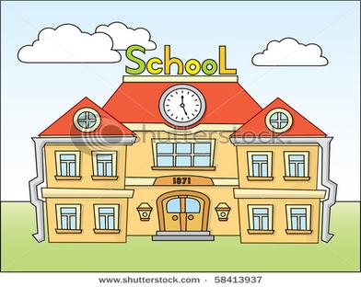

What are you learning at home that you can use at school?

1. I have learned       at home, and I will use it at

 by      .

2. I have learned       at home, and I will use it at

 by      .

3. I have learned       at home, and I will use it at

 by      .

**Making the Connection between School and Community**

**** and 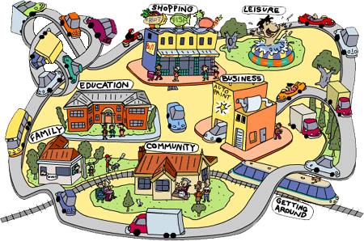

What are you learning at school that you can use in the community?

1. I have learned       at school, and I will use it in the

 by      .

2. I have learned       at school, and I will use it in the

 by      .

3. I have learned       at school, and I will use it in the

 by      .

**Creating Connections Summary**

List all of your activities that seem important to you. Tell why each is important. Then, go back to the beginning of your list, and circle all of those activities that will help you when you are an adult.

**What I Do Why it is Important**

|  |  |
| --- | --- |
|  |  |

**Setting My Own Goals**

Name:

Date:

My short range goal is:

I plan to accomplish by doing the following things:

My long range goal is:

I plan to accomplish by doing the following things:

**Health Care Questionnaire**

Answer the questions below by checking the Yes or No box. **YES NO**

1. Do you need to wear glasses?

2. Do you have difficulty hearing?

3. Do you wear a hearing aid?

4. Do you get colds frequently?

5. Do you have frequent stomachaches or indigestion?

6. Do you have trouble sleeping?

7. Do you have extreme thirst?

8. Are you frequently depressed?

9. Do you have dizzy spells?

10. Are you tired all the time?

11. Have you ever been in a serious accident?

12. Have you ever been hospitalized?

13. Do you have bad reactions to insect bites or bee stings?

14. Do you think you might ever want to smoke, drink alcohol or

take drugs?

**Personal Health Facts**

Name:

Answer each question by marking an "X" in any box where the answer is “YES.” Use the space on the right side of the page to explain your "YES" answers.

|  |  |
| --- | --- |
|  | **YES** |
| 1. Do you have any allergies that might limit the types of environments in which you can work? |  |
| 2. Do you have any physical disability that would prevent you from lifting or moving heavy objects? |  |
| 3. Do you have any sight problems? |  |
| 4. Do you need to wear glasses when doing some tasks? |  |
| 5. Are you color blind? |  |
| 6. Do you have any hearing problems? |  |
| 7. Do you wear a hearing aid? |  |
| 8. Do you tend to stumble and fall easily? |  |
| 9. Do you have limited use of either hand? |  |
| 10. Are you slow or clumsy with your hands? |  |
| 11. Do you have, or have you had, seizures or convulsions? |  |
| 12. Have you had a significant head injury? |  |
| 13. Do you have any speech problems that might make it difficult for others to understand you? |  |
| 14. Do you become tired quickly so you would not be able to work a full day? |  |

|  |  |
| --- | --- |
| 16. Do you require medication for juvenile diabetes? |  |
| 17. Do you require medication for asthma? |  |
| 18. Do you take any medications on a regular basis that might make it difficult or unsafe for you to work at some jobs? |  |
| 19. Do you know of any adaptations or special arrangements that might be made to help you perform a job more easily, more safely, or more efficiently? |  |

If "yes" is your answer to number 19, list the accommodations you will need:

**Me, Not Me Characteristic Cards**

 

 

 

**Me, Not Me Characteristic Cards**

 

 

 

**Me, Not Me Characteristic Cards**

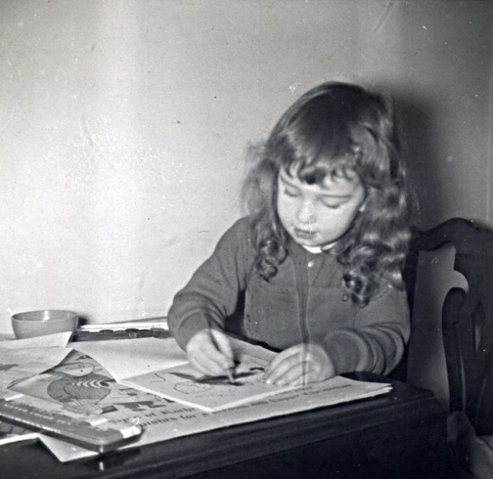 

** **

** **

**My Personal Evaluation**

Name:

Date:

This is a “Self-Help Check-Up.” There are no right or wrong answers. Only YOU can know what is right for you. This is your own personal guide to self-discovery. Answer these questions as honestly as you can.

Am I my own best friend?

How could I treat myself better?

What are my strengths, my best points?

What faults or weaknesses am I willing to work on?

What small thing could I begin to work on today to start my self-improvement?

Do I *really*love myself?

Do I love others?

Write the name of someone you love.

Do I have friendships with others?

Write the name of afriend.

**My Personal Evaluation**

What small thing could I do now that could start or improve a friendship?

What is my opinion of the way my body looks?

What are my best health habits?

What are my worst health habits?

What small thing could I do now that could improve my health?

Am I happy with how things are going in school?

What could I do to improve my school situation?

**Self-Scale/Frustration Graph**

Mark the spot on the line that represents how you see things:

Place an **X** to show where you think you are right now.

Place another **X** to show where you would really like to be.

|  |
| --- |
| **FAMILY** |
| NOT GOOD          BEST |
| **GRADES** |
| NOT GOOD          BEST |
| **FRIENDS** |
| NOT GOOD          GREAT |
| **PEERS** |
| NOT GOOD          GREAT |
| **BODY** |
| NOT GOOD          GREAT |
| **PERSONALITY** |
| NOT GOOD          GREAT |
| **HOW SMART I AM** |
| NOT GOOD          GREAT |

**Defining Stress #1**

To be stressed is to feel pressure. Different situations create different levels of stress for different people. Not all stress is bad; sometimes stress is what makes us more productive and better workers. Identify the feelings you would probably have in the situations given below. You might respond with more than one feeling to a situation. Write the letter in the box next to each number that best describes the feeling for each situation.

|  |  |
| --- | --- |
| **Situation** | **Feeling** |
| 1. You have just moved into a new neighborhood | 1. Embarrassment |
| 1. You are going to speak in front of the entire class | 1. Anger |
| 1. You have little time in which to complete three lengthy homework assignments | 1. Frustrations |
| 1. You have broken you mom’s favorite antique and are unsure what to do next | 1. Nervousness |
| 1. Your friends have made fun of how you look | 1. Loneliness |
| 1. A friend needs help and you are unwilling to assist at this time | 1. Impatience |
| 1. A friend is late for school and you are going to miss the bus if he or she does not come soon | 1. Boredom |
| 1. Your parent will not let you go to the dance to which everyone else is going | 1. Overwhelmed |
| 1. Your friends are busy this weekend and you are left at home by yourself with nothing to do | 1. Guilt |
| 1. You have tried out for the school choir three times and have not been selected | 1. Contentment |
| 1. Your pet is very sick and must stay at the vet’s   **Defining Stress #1** | 1. Failure |
| 1. It is Friday afternoon, you are going roller skating with your best friend, and your mom just handed you a $5 bill | 1. Joy |
| 1. Your dad just announced that he has won the lottery | 1. Sad |

**Defining Stress #2**

Decide which situations *you* think would make you feel the worst. Number the pictures. Use 1 for the worst that can happen. Use 4 for the least difficult situation.

**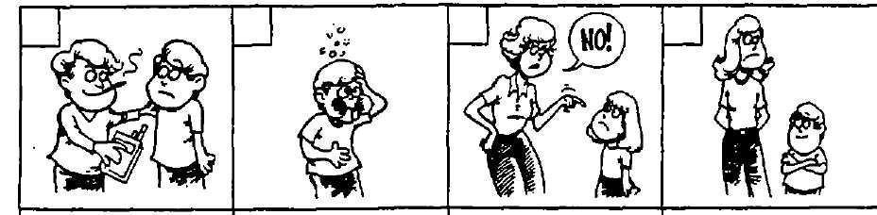**

    Being pressured to try something new

    Feeling sick

    Fighting with parents about house rules

    Being overweight or bigger than others your age

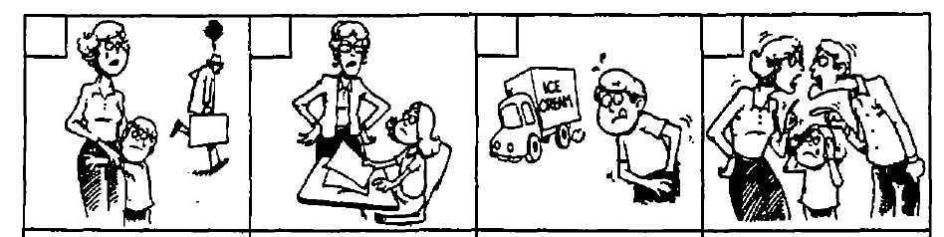

    When parents separate

    Not getting along with your teacher

    Not having enough money to spend

    When your parents argue in front of you

**Defining Stress #2**

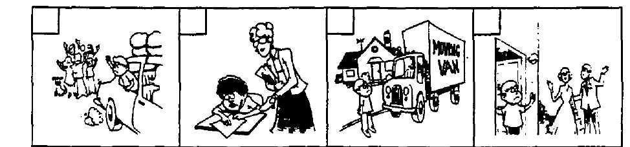

    Changing schools

    Not having homework completed on time

    Moving from one place to another

    Not spending enough time with your mom or dad

Answer these questions:

1) Number     is the least difficult situation because:

2) Number     is the worst situation because:

**Defining Stress #3**

How would you rank the following situations? Number each situation below with the number that represents how you'd feel.

Write “1” on the line if the situation is *highly* stressful. Write “2” on the line if the situation is *somewhat* stressful. Write “3” on the line if the situation is *not* stressful at all.

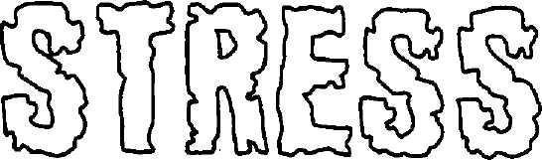

|  |
| --- |
| Introducing yourself to a stranger at a party |
| Asking a parent for money |
| Apologizing for doing something wrong to a friend |
| Camping in the woods for three days |
| Flying in an airplane |
| Taking a test at school |
| Speaking to a large group of people |
| Shooting the basketball with two seconds left in a tied game |
| Getting an injured arm examined by a doctor |
| Attending the funeral of a grandparent |
| Attending the first day of class at a new school |
| Turning in a late assignment. |
| Hearing that your parents are getting a divorce. |
| Being sent to the principal’s office for bad behavior |
| Going shopping for clothes |
| Having a really bad nightmare |

**Do you Create Stress for Someone?**

MC900437563[1]

Sometimes our behavior causes stress in other people's lives. Identifying such behavior allows us to make changes which result in better relationships with others.

Do people sometimes find it necessary to cope with *you*? Think of a situation in each category where you have been the cause of stress for others. Briefly describe

each situation below.

|  |  |
| --- | --- |
| At School: |  |
| At Home: |  |
| With Friends: |  |

:

**Finding Solutions!**

Please read each story carefully. Write what you would do.

**Foreign Foods**

You are invited to a new friend's house for dinner. When you sit down with the family to eat, you discover the entire meal consists of foods you absolutely cannot stand! What could you do?

**Loss of a Friend**

Your best friend suddenly begins to ignore you and starts spending time with someone else. You thought the situation would be temporary, but you realize your friend no longer values your friendship. How would you deal with this situation?

**Birthday Blues**

You have invited several friends for a party to celebrate your birthday. On the morning of the party, however, your mom wakes up very, very ill with the flu. What can you do?

**Boredom**

It is a stormy Saturday. You are home and unable to talk with your friends because telephone and electrical wires will be out of use for several hours. The TV and radio are also out of order. Tell how you would go about enjoying this unusual Saturday afternoon.

**Write Your Own**

**My Self-Evaluation**

|  |  |  |  |  |
| --- | --- | --- | --- | --- |
| **Daily Self-Evaluation** | **Always** | **Usually** | **Sometimes** | **Never** |
| Come to school every day. |  |  |  |  |
| Come to school on time. |  |  |  |  |
| Bring a pen/pencil to class. |  |  |  |  |
| Participate in class discussions. |  |  |  |  |
| Turn in your homework on time. |  |  |  |  |
| Finish class work on time. |  |  |  |  |
| Get along with other students.\* |  |  |  |  |
| Get along with teachers.\* |  |  |  |  |

\* Determined by following class and school rules (e.g., no problems with talking inappropriately, name calling, etc.)

**Specific Daily Time Counts**

Name

Date

Each section of the circle represents one hour of the day. Mark the circle in sections showing the amount of time you spend doing various activities throughout the day.

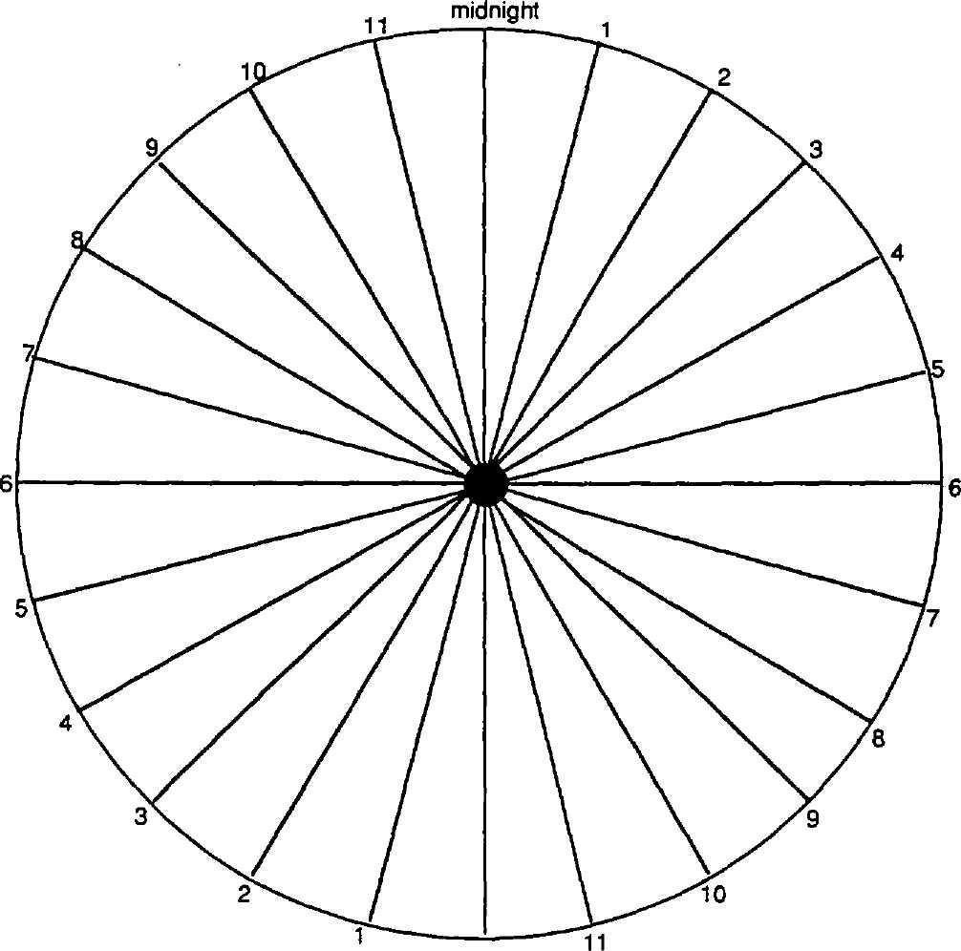

**noon**

**Specific Time Counts — How I Spend My Time**

Name

I spent the most time      .

The time I enjoyed the most was spent      .

The time I enjoyed the least was spent      .

The most useful thing I did was      .

I wasted my time when I      .

If I could use my time anyway I pleased, I would spend more time      .

I spent       watching T.V.

**Tasks I Do at Home**

Write down how much time you spend each day doing the following activities:

|  |  |  |  |  |  |
| --- | --- | --- | --- | --- | --- |
| **Chore** | **Monday**    **MONDAY** | **Tuesday**    **TUESDAY** | **Wednesday**  **WEDNESDAY** | **Thursday**    **THURSDAY** | **Friday**    **FRIDAY** |
| Take out the trash |  |  |  |  |  |
| Feed pet |  |  |  |  |  |
| Put away clothes or toys |  |  |  |  |  |
| Make bed |  |  |  |  |  |
| Help with dishes |  |  |  |  |  |
| Other chores |  |  |  |  |  |

**How Much T.V. Time?**

Use the shading tool on your computer (looks like a paint bucket) to paint a block for every ½-hour of television you watch on a school day/night.

|  |  |  |  |  |  |  |  |  |  |
| --- | --- | --- | --- | --- | --- | --- | --- | --- | --- |
| ½ hour | 1 hour | 1 ½ hours | 2 hours | 2 ½ hours | 3 hours | 3 ½ hours | 4 hours | 4 ½ hours | 5 hours |
|  |  |  |  |  |  |  |  |  |  |

Use the shading tool to paint a block for every ½-hour of television you watch on Saturday (weekend).

|  |  |  |  |  |  |  |  |  |  |
| --- | --- | --- | --- | --- | --- | --- | --- | --- | --- |
| ½ hour | 1 hour | 1 ½ hours | 2 hours | 2 ½ hours | 3 hours | 3 ½ hours | 4 hours | 4 ½ hours | 5 hours |
|  |  |  |  |  |  |  |  |  |  |
| 5½ hours | 6 hours | 6½ hours | 7 hours | 7 ½ hours | 8 hours | 8 ½ hours | 9 hours | 9 ½ hours | 10 hours |
|  |  |  |  |  |  |  |  |  |  |
| 10 ½ hours | 11 hours | 11 ½ hours | 12 hours | 12 ½ hours | 13 hours | 13 ½ hours | 14 hours | 14 ½ hours | 15 hours |
|  |  |  |  |  |  |  |  |  |  |

Use the shading tool to paint a block for every ½-hour of television you watch on Sunday (weekend).

|  |  |  |  |  |  |  |  |  |  |
| --- | --- | --- | --- | --- | --- | --- | --- | --- | --- |
| ½ hour | 1 hour | 1 ½ hours | 2 hours | 2 ½ hours | 3 hours | 3 ½ hours | 4 hours | 4 ½ hours | 5 hours |
|  |  |  |  |  |  |  |  |  |  |
| 5½ hours | 6 hours | 6½ hours | 7 hours | 7 ½ hours | 8 hours | 8 ½ hours | 9 hours | 9 ½ hours | 10 hours |
|  |  |  |  |  |  |  |  |  |  |
| 10 ½ hours | 11 hours | 11 ½ hours | 12 hours | 12 ½ hours | 13 hours | 13 ½ hours | 14 hours | 14 ½ hours | 15 hours |
|  |  |  |  |  |  |  |  |  |  |

What kinds of things might you do instead of watching television?

**My Daily Time Graph**

**Developing a Schedule**

Determine how you spend a typical 24-hour day:

Enter the number of hours you spend on each activity.

If the time entered is less than one hour, use “0” in the space.

Then, print this page to color in the “clock’s hours,” and watch as your time slips away.

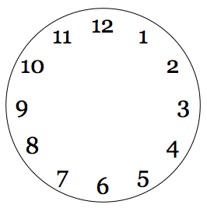

     School      Work      Transportation

     Homework      Family      Relaxing

     Sleeping      Personal care      Friends/Entertainment

     Exercise/Sports      Meals      Other

**A Weekly Time Log**

Fill out your present weekly schedule. Be sure to include sleeping time, eating time, class time, job time, social time (friends or recreation), time with family, time alone, and study time.

|  |  |  |  |  |  |  |  |
| --- | --- | --- | --- | --- | --- | --- | --- |
|  | **Sunday** | **Monday** | **Tuesday** | **Wednesday** | **Thursday** | **Friday** | **Saturday** |
| **6 a.m.** |  |  |  |  |  |  |  |
| **7 a.m.** |  |  |  |  |  |  |  |
| **8 a.m.** |  |  |  |  |  |  |  |
| **9 a.m.** |  |  |  |  |  |  |  |
| **10 a.m.** |  |  |  |  |  |  |  |
| **11 a.m.** |  |  |  |  |  |  |  |
| **12 p.m.** |  |  |  |  |  |  |  |
| **1 p.m.** |  |  |  |  |  |  |  |
| **2 p.m.** |  |  |  |  |  |  |  |
| **3 p.m.** |  |  |  |  |  |  |  |
| **4 p.m.** |  |  |  |  |  |  |  |
| **5 p.m.** |  |  |  |  |  |  |  |
| **6 p.m.** |  |  |  |  |  |  |  |
| **7 p.m.** |  |  |  |  |  |  |  |
| **8 p.m.** |  |  |  |  |  |  |  |
| **9 p.m.** |  |  |  |  |  |  |  |
|  |  |  |  |  |  |  |  |
|  |  |  |  |  |  |  |  |

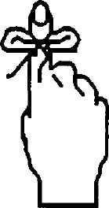 **TODAY**

Write out a schedule for the day. Now, put an asterisk (\*) next to those items you MUST do. At the end of the day, ask yourself, “Were my goals completed?” If not, what interfered with the completion of your goals? If your goals were accomplished, reward yourself!

**\***

|  |
| --- |
|  |
|  |
|  |
|  |
|  |
|  |
|  |
|  |
|  |
|  |
|  |
|  |
|  |
|  |
|  |

**To Do List**

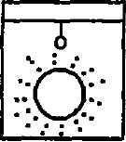 

Things to do this morning

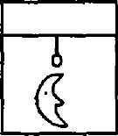

Things to do tonight

**Setting My Own Goals #2**

Let’s list five daily responsibilities at home or school on the chart below. Then, list the consequences of not following through, and identify *who* will be affected if you do not follow through with your responsibilities.

|  |  |  |
| --- | --- | --- |
| **Responsibility** | **Consequence** | **Who is Affected** |
| 1.    2.  3.  4.    5. |  |  |

**Setting My Own Goals #3**

Name:

Date:

My short range goal is:

I plan to accomplish this by doing the following things:

My long range goal is:

I plan to accomplish this by doing the following things:

**An Unbeatable Team**

      and       want to get over these humps. They have agreed to help one

another.       will help       by      .       will help      . And,

      will help      by      . When they reach their goals, they will

be able to      .

                 

Student Signature Date Student Signature Date

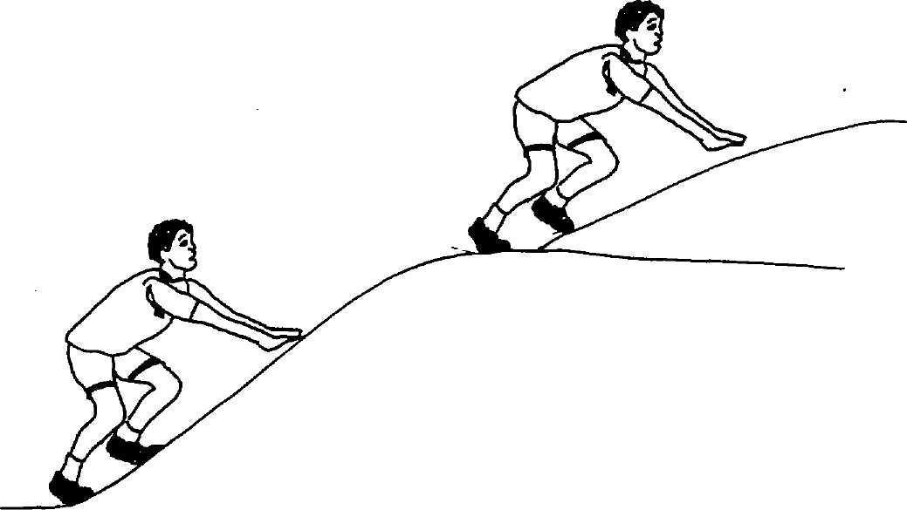

**Batter Up—Home Run**

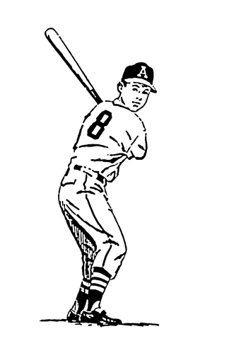

My Goal is to:      .

When I touch 1st base:      .

When I touch 2nd base:      .

When I touch 3rd base:      .

When I touch home plate:      .

I will hit a home run. Then, I will be able to:

Student Signature Date Coach’s Signature Date

Adapted from Innovative Educational Systems

**Beat Your Own Record**

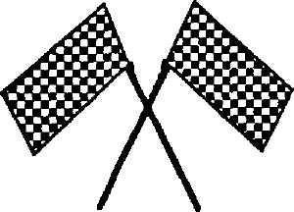

By      ,       agrees to      .

      will help       by      .

When they win, they can celebrate by      .

DATE OF RACE:

     

1st Driver’s Signature Date

     

2nd Driver’s Signature Date

3rd Driver’s Signature Date

Adapted from Innovative Educational Systems

**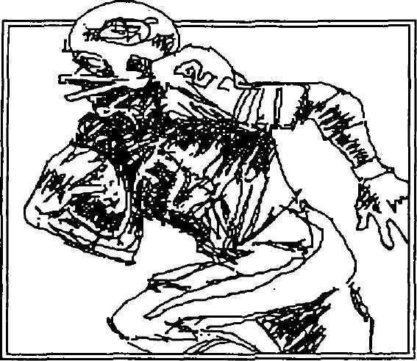Touchdown!**

Here's my goal:

I will reach my goal and score by completing the following tasks:

50 yard line:

40 yard line:

30 yard line:

20 yard line:

10 yard line:

Goal line:

During halftime, I would like to:      .

As a victory celebration I will be able to:      .

                 

Quarterback’s Signature Date Coach’s Signature Date

Adapted from Innovative Educational Systems

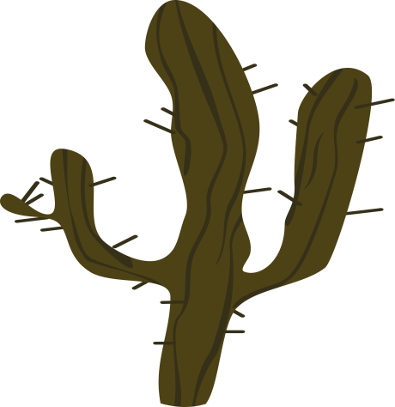

**I’m not** **Stuck**

I can      .

I will have it finished by       if       will help by      .

I’d like to celebrate when I finish by      .

     

Signature of Unstuck Student Date

Signature of Teacher

Signature of Teacher

**Work Awareness List**

How many occupations can you name in 5 minutes?

|  |  |  |  |
| --- | --- | --- | --- |
| 1 |  | 20 |  |
| 2 |  | 21 |  |
| 3 |  | 22 |  |
| 4 |  | 23 |  |
| 5 |  | 24 |  |
| 6 |  | 25 |  |
| 7 |  | 26 |  |
| 8 |  | 27 |  |
| 9 |  | 28 |  |
| 10 |  | 29 |  |
| 11 |  | 30 |  |
| 12 |  | 31 |  |
| 13 |  | 32 |  |
| 14 |  | 33 |  |
| 15 |  | 34 |  |
| 16 |  | 35 |  |
| 17 |  | 36 |  |
| 18 |  | 37 |  |
| 19 |  | 38 |  |

**Who is This Person?**

**Question Cards**

|  |  |
| --- | --- |
| When you are done shopping, who takes your money and runs the cash register? (cashier) | Who puts your groceries in bags and sometimes helps you carry them? (grocery packer) |
| 3. Who is in charge of the whole store and makes sure everything runs smoothly? (manager) | Who often wears a white apron, cuts meat and helps you find meat? (butcher) |
| 5. Who helps clean the store so it is neat and safe? (custodian) | Who helps bake the bread and cookies and stays by the pies and cakes? ( baker) |
| Who helps us find bologna, potato salad and turkey? (deli operator) | Who sometimes brings groceries to our house when we call and order? (delivery person) |
| Who works for the government and makes everything is safe and clean? (inspector) | Who goes to the grocery store and brings food for the family? (we do) |

**Which Cluster Includes This Person's Job?**

Marine Biologist

Tree Surgeon

Horticulturist/Landscaper

Salesperson

Cashier

Computer Programmer

Buyer

Jeweler

Editor

Radio/TV Announcer

Telephone Operator

Drafting/Architect

Auto Body Repair Specialist

Taxi Driver

Air Traffic Controller

Truck Driver

Railroad Worker

Bus Driver

**The Who’s Who Interview Form**

Choose one working member of your family to interview. Ask that individual to help you answer the following questions.

1. Relationship to you:

2. Name of occupation:

3. Needed skills, education, and training (how many years of each)

4. Important aptitudes, abilities and skills

5. Work environment (in an office, outside, crowded, alone, noisy, quiet, etc.)

6. Personal interests that are needed

7. Salary range $

8. What skills that were learned in early school years are now necessary for success on this job?

**The Who's Who Interview:**

**Jobs and School Skills**

Directions: Place the number of the job title next to the matching school skill.

**Job Titles School Activities**

1. Artist     Working with numbers

2. Custodian     Showing boys and girls how to learn

3. Teacher     Studying space

4. Gardener     Checking out books

5. Actor     Cleaning the classroom

6. Librarian     Taking part in a class play

7. Mathematician     Caring for class pets

8. Secretary     Painting a picture

9. Astronaut     Planting a class garden

10. Veterinarian     Taking notes during a class meeting

**Career Satellite**

Think of a career that would seem just right for you. Write it in the middle circle. Then, research at least four details about that career, and write those in the smaller circles. Details could include education requirements, pay, some of the tasks you would be expected to do, etc.

**Self-Portrait**

Please print this page. Draw a picture of yourself at work. (This does *not* have to be an artistic masterpiece.)

In a short sentence, tell about your picture.

**Career Awareness Jeopardy**

|  |  |  |  |  |
| --- | --- | --- | --- | --- |
| **Make the Connection: More Jobs** | **All Workers Need…** | **Jobs, Jobs, and More Jobs** | **What do**  **You Think?** | **Pot Luck** |
| Name two things you have learned at home and use at school.  $200.00 | Name four characteristics that all workers need.  $200.00 | Name four jobs under the occupational area of recreation.  $200.00 | Do you think most people stay with the one career they established during their 20s (age)?  $200.00 | $200.00 |
| Name two things you have learned at school and use at home.  $300.00 | Name six characteristics all workers need.  $300.00 | Name five jobs under the occupational area of medical care.  $300.00 | What do you think you can do now to learn more about careers?  $300.00 | $300.00 |
| Name three things you have learned at school and use at home.  $400.00 | Name eight characteristics all workers need.  $400.00 | Name six jobs under the occupational area of natural resources or science.  $400.00 | Do you think it’s smart to find out about lots of careers before you decide what you’ll be? Why or why not?  $400.00 | $400.00 |

**My Personal Habits**

Directions: Write yes, no, or sometimes in the blanks in the right column. You will be creating your own rules for appropriate behavior and hygiene.

|  |  |  |
| --- | --- | --- |
| 1 | I appear in public with my hair clean and brushed. |  |
| 2 | I dress appropriately for the place and the activity. |  |
| 3 | I chew with my mouth open. |  |
| 4 | I smile when I greet people. |  |
| 5 | I treat others as though they were people, too. |  |
| 6 | I say “hello,” “goodbye,” and “thank you.” |  |
| 7 | I snap or pop my gum as I'm waiting. |  |
| 8 | I brush my teeth and wash my face every morning. |  |
| 9 | I look people in the eye when I'm talking to them. |  |
| 10 | I introduce friends who come to my home to my parents. |  |
| 11 | I offer help in situations where there is something I can do. |  |
| 12 | I thank people who go out of their way to do something nice for me. |  |
| 13 | I thank my friend and his/her parents after eating a meal or spending the night at his/her house. |  |

**How Would You Respond?**

**Situation Cards**

|  |  |
| --- | --- |
| You look nice today. | You did a nice job on this paper. |
| You forgot to comb your hair this morning. | I like your new shirt. |
| I’m not happy with your behavior today. | I appreciate the way you played with Chris at recess. |
| I don’t appreciate the way you pushed me in line. | Ha! Ha! I did it better than you. |

**What’s in a Walk? Cards**

|  |  |
| --- | --- |
| Stomp | Shuffle |
| March | Stroll |
| Jaunt | Skip |
| Scurry | Bolt |
| Stride | Slouch |

|  |  |
| --- | --- |
| Angry; Mad | Happy; Glad |
| Depressed; Sad | Hurry |
| Determined | Hurried |
| Carefree | Confident |
| Superior | Lazy |

**Role-Play Situations**

Someone who has just lost their pet

The friend of someone who has lost their pet

Someone who has to move

The best friend of someone who has to move

Someone who just won a prize in a contest

The friend of someone who has just won a prize

Someone who’s going to the Bahamas for vacation

Someone whose family doesn’t have extra money

Someone whose brother just died in a car accident

A classmate of someone whose brother just died in a car accident

Someone who has just cheated on a test

A friend of someone who has just cheated on a test

**Gathering Facts**

If you need help, ask your parents for assistance in completing the chart.

|  |  |  |
| --- | --- | --- |
|  | **Mother** | **Father** |
| First and middle name |  |  |
| Date of birth |  |  |
| Present Age |  |  |
| Number of brothers and sisters |  |  |
| Present type of employment |  |  |
| Favorite color |  |  |
| Favorite food |  |  |
| Greatest achievement to date |  |  |
| Most important possession |  |  |
| Unfulfilled dream |  |  |
| What in life is most valued |  |  |

**Student Polling Questions**

What do you like most about our school?

Name of student #1:       Age:

Response:

Name of student #2:       Age:

Response:

Name of student #3:       Age:

Response:

Add this information to the “Student Survey Chart” in your classroom. Study the answers of several students to determine what people like about your school.

**Student Polling Opinions**

Interview two students whom you don't know very well. Ask the following questions and record their answers in the space below.

|  |  |  |
| --- | --- | --- |
| Student Name | Age | What do you like most about our school? |
|  |  |  |
|  |  |  |

Add this information to the “Student Survey Chart” in your classroom. Study the answers of several students to determine what people like about your school.

Now interview two teachers. Ask the following questions and record their answers in the space below.

|  |  |
| --- | --- |
| Teacher Name | What do you like most about our school? |
|  |  |
|  |  |
| Teacher Name | What do you like best about your job? |
|  |  |

Determine one thing teachers and students like best about the school. Complete this sentence:

**Many people like this school because:**

**Employment Questions**

1. What is your name?

2. What is your occupation?

3. Who do you work for?

4. When did you choose this career?

5. How did you happen to choose your career?

6. What are the main skills needed?

7. What training do you have?

8. What tools or equipment do you use?

9. Do you work indoors, outdoors, or both?

10. What are your working hours?

11. What do you like about your work?

12. What would you change about your work?

13. What are the main benefits of this career?

**Employment Questions**

14. Student Question

15. Student Question

16. What did you learn in elementary school that you use in your work now?

**True or False**

Put a **T** in front of *true* statementsand **F** in front of *false* statements**.**

|  |  |  |
| --- | --- | --- |
| **#** | **T or F** | **Statement** |
| **1** |  | All baby girls wear pink booties. |
| **2** |  | Boys and girls are both people. |
| **3** |  | Boys aren't supposed to cry. A boy who cries is a sissy. |
| **4** |  | Girls are the weaker sex. |
| **5** |  | Girls are made out of sugar and spice and everything nice. |
| **6** |  | Boys are made out of snips and snails and puppy dog tails. |
| **7** |  | Half the people in the world are males and half are females. |
| **8** |  | Girls aren't supposed to fight, but it is okay for boys to fight. |
| **9** |  | Girls are softer-hearted and kinder than boys. |
| **10** |  | Boys hit and punch when they fight. |
| **11** |  | Girls scratch and pull hair when they fight. |
| **12** |  | Girls talk more than boys. |
| **13** |  | Boys are more active than girls. |

“A disability is an impairment of structure or function. It becomes a handicap when the individual perceives it as a barrier to his potential for work or play. If you are born with a disability and you allow it to hinder your functioning, then I’d call it a handicap, but if you do things another way in spite of the disability, then it’s simply a matter of inconvenience.”

Mama Cass, Mamas and the Papas

**Search and Research**

Please “research” the following questions. You will need to ask older family members to help answer these questions. Use additional paper, if necessary.

1. What is the origin of your last name? What is its meaning? What, if any, changes did your family surname undergo when/if your ancestors came from another country to the United States?

2. What have been passed on to you about your parents? Grandparents? Ancestors? What do you know about your parents’ or other ancestors’ childhood, religion, politics, schooling, leisure activities, attitudes about death, etc.?

3. What languages have been important in your family’s past and present? Are there any ties to a “homeland?”

4. How did your parents, grandparents, great-grandparents, etc. come to meet and marry? Are there family stories about these relationships (e.g., jilted brides, brief courtships, elopements, etc.)?

5. What historical events affected your family most?

6. Is there a famous or notorious person in your family’s past? What can you tell about him/her?

7. What traditional names have been used in your family? Nicknames? Are there any naming traditions?

8. What traditions have been handed down to you from your family? What traditions seem to be dominant in your family’s history?

**Search and Research**

9. Are there any special family recipes that have been preserved and handed down from generation to generation in your family? Are they still in use today?

10. Are there reunions held among members of your family? How often? When and where? Who organizes the reunions? Who is invited? Who comes? Are there traditional foods and activities? Are stories and photographs exchanged? Are records of the reunions kept? Are there relatives you are happy to see during these reunions? Are there relatives you’re not so happy to see?

**Preconceived Ideas**

Let's suppose it's the week before Christmas, and you're given the task of buying a present for each of the following people:

1. Harry Skinner, a cab driver

2. Marsha Truelove, a Red Cross volunteer

3. Freddy Faster, a sixth-grade “A” student

4. Abigail Watson, a senior citizen

Which of the following gifts would you choose for each? Write the name of the person next to the gift you chose.

* A desk dictionary
* A rocking chair
* Two tickets to the opera
* A pair of skis
* A leather jacket
* A makeup kit
* A Michael Jackson CD
* A first-aid kit

**Did you choose:**

* The leather jacket for Harry because “it's the kind of clothing a cab  
  driver wears?”
* The first-aid kit for Marsha since “it may come in handy the next time  
  she helps out in an emergency?”
* The desk dictionary for Freddy who “can always use a dictionary to  
  help him with his studies?”
* The rocker for Abigail who “probably doesn't get around too much and  
  who spends most of her time staring out the window?”

No doubt these are the “usual” choices. But, the people on our list happen to be “unusual.” They don't fit into such neat categories.

*Harry* is a voice student who drives a cab in his spare time. He has nothing against leather jackets, but he'd prefer the opera tickets. He hopes to become an opera singer one of these days.

**Preconceived Ideas**

At 16, *Marsha* thinks Michael Jackson is “super.” She listens to his CDs while doing volunteer work in the Red Cross CPR class every week. She doesn’t need a first-aid kit to clean the mannequins used to teach breathing.

*Freddy* is working on a clown routine for the school talent show right now. A make-up kit would help his act a lot more than a dictionary would.

Born in Idaho, *Abigail* still enjoys skiing down a powdery slope on a brisk winter's day. She would put those new skis to good use, and has no need of a rocking chair just yet.

Did the labels on these people mislead you into making the “usual” choices? But, your assumptions can be wrong! To know a person well you need a great deal of information, more than you'll find on a label. With nothing but a word or two to build from, your mind produced a stereotyped picture rather than the true one.

*In printing, a “stereotype” is a metal plate, which reproduces the same picture over and over. In thinking, a stereotype is a mental picture. It has all people in a particular group looking and acting the same way. Stereotypes can cloud our judgment because they ignore the fact that no two human beings are identical. People, each and every one, are different.*

Take the cab driver, for example. In your mind, did you picture him as a middle-aged, rugged, boisterous, gabby family man? That is one stereotype of a “cabbie” like the one you usually see on TV, or in movies. But, real cab drivers can be young or old, sensitive, educated, soft-spoken, shy, unmarried, and either male or female. Be careful that you don't think in stereotypes!

Here are some other examples of stereotypes. Do you recognize them?

1. She wears her hair tied in a bun. She wears horn-rimmed glasses. She's unmarried. She's always saying “shh” to people. She spends her days surrounded by books.

She is a      .

**Preconceived Ideas**

2. He's fast talking and fast moving. His secretary will do any task he asks.

He's fearless and can take a beating as well as give one. He's really clever and usually outwits the police. His clients often include beautiful women.

He is a      .

3. She's a big, meddlesome lady with a loud voice. She pays surprise visits to her children. She's fond of saying, “my poor baby.” She has been known to wreck some marriages. She likes to spoil her grandchildren.

She is a      .

How true-to-life are these stereotypes? Usually, a stereotype has some truth to it. There probably are some librarians who wear their hair in a bun and mothers-in-law who are pests. But, there are many more who do not fit these descriptions. The danger in the stereotype is that it distorts our understanding of people by ignoring their differences.

Some adults have a way of stereotyping young people. Perhaps, you have heard their argument. It goes something like this:

“You kids are all alike. You show no respect for your elders, you have poor manners, and your speech is as sloppy as your dress. You don't realize how good you have it. Now, in my day…”

The harm there is that the person who believes in this stereotype may act on this belief. In the case just mentioned, you, as a young person, would be the victim. Maybe you've already had the experience. Have you ever met a merchant who doesn't trust kids in his store? A bus driver who hates all kids who go to that school on the hill? A teacher who is suspicious of a boy with long hair?

Stereotypes are often used by the mass media—by TV, advertising, the movies, magazines, comics, etc. Sometimes, these stereotypes are amusing and entertaining. The hen-pecked husband, the absent-minded professor, and the bearded hippie all make us laugh because they are such exaggerations of the real thing.

**Preconceived Ideas**

The mass media rely on the fact that all of us have certain stereotypes in our heads. For example, the column at the left lists a number of different types of people. Can you match the person to the quality in the right-hand column with which he or she is usually associated? Place the number of the person (left column) in front of the perceived characteristic (right column).

1. Blondes    lack of respect for adults

2. Fat people    aren’t scholars

3. Redheads    smoke cigars

4. Athletes    have more fun

5. Professors    are glamorous

6. Politicians    are hot-tempered

7. Teenagers    are always jolly

8. Actresses    are absent-minded

Stereotypes distort the truth. They suggest that all people in a particular group behave in the same way. They also suggest that only these people behave that way. Neither is true.

When people begin to stereotype others on the basis of their race, religion, or nationality, the result is “prejudice.” Archie Bunker, the fatherly bigot of TV's “All in the Family,” is guilty of this. Archie, like most bigots, sees only what he wants to see. Instead of judging people on their merits and abilities, he identifies them with a race or religion or nationality and then, either praises or blasts them.

It is important to remember that no one group in our society has a monopoly on brawling, laziness, ignorance, foreign accents, drinking, crime, greed, pushiness, etc. Nor does any one group have a monopoly on beauty, brains, glamour, strength, humor, talent, etc. Every group has its share of all of these human qualities.

**Preconceived Ideas**

To be sure, a certain amount of stereotyping is bound to occur. We all do it, usually without thinking about it. But, it's a good idea to remember that no two people in the world are identical. Thus, no label can be pasted on an individual or group that truly describes that person or group.

*After all, labels belong on products, not people.*

When a trout rising to a fly gets hooked on a line and finds himself unable to swim about freely, he begins with a fight, which results in struggles and splashes and sometimes an escape. Often, of course, the situation is too tough for him.

In the same way, the human struggles with his environment and with the hooks that catch him. Sometimes, he masters his difficulties; sometimes, they are too much for him. His struggles are all that the world sees, and it naturally misunderstands them.

It is hard for a free fish to understand what is happening to a hooked one.

Karl A. Menninger

**What to Do?**

What should you do when you have a problem? Here are some steps to help you make good decisions.

1. Identify the problem. What is wrong? Focus your ideas so you can put your finger on exactly what’s going on.

2. Do you need further information? More facts? More Feedback?

3. List the possible solutions. What are the three things you can do?

a.

b.

c.

4. Identify the consequences of each choice you could make. What if…?

a.

b.

c.

5. Look over the choices and consequences. Which is your best option? What’s your decision?

**Smart Selections**

Place an “X” in front of the letter that best describes your response to each scenario and question.

1. When you get home from school, you open the front door, and your dog runs out. He runs past your house and the next house and far out of sight. You are  
worried he will get lost. What would you do?

a. Run after him.

b. Call the fire department.

c. Call a neighbor immediately.

d. Call one of your parents, and ask what to do.

2. Let's say you have a younger brother who puts a toy boat in the toilet and  
flushes it down. Now, the toilet is overflowing. What would you do?

a. Call the phone operator for help.

b. Call one of your parents.

c. Run to a neighbor's house immediately.

d. Reach behind the toilet to the valve supplying water, and turn the handle  
 to close it. Then, mop up the water.

3. You are watching TV in the living room. You smell smoke coming from the kitchen. You see the curtains are on fire. What would you do?

a. Try to put the fire out.

b. Call the fire department.

c. Call one of your parents.

d. Run immediately to a neighbor you know is home. Then, call both the fire department and one of your parents.

4. When you get home from school or day camp, you notice that a window is  
broken. It wasn’t that way in the morning. You go in and see that the living  
room furniture has been pushed around, and drawers have been dumped on  
the floor. The same thing is true in the kitchen. What would you do?

a. Straighten up the mess before your parents come home.

b. Call the police.

c. Call one of your parents.

d. Run to a neighbor's house immediately. Then, call the police.

**Smart Selections**

5. The burglar system starts to ring. You are inside reading a book. What would  
you do?

a. Run to a room with a lock on the door, lock it, and call the police.

b. Run to a neighbor's immediately.

c. Hide under your bed.

d. Try to turn off the alarm.

6. Here are four rules to follow when walking home from school. One does not  
belong. Which is it?

a. Wear a tall hat, so you seem bigger than you are.

b. Cross the street only at the corner.

c. Obey traffic signs and signals.

d. Walk, facing the traffic, if you have to go down a road with no sidewalk.

7. A teenage boy comes to your door. You have never seen him before. He wants  
to come in, and show you some magazines you could buy. What would you do?

a. Tell him you are not interested. Do NOT unlock the door.

b. Invite him in.

c. Tell him to come back later when your parents are home.

d. Call the police.

8. You get a small cut on your arm. Here is a list of things to do to make it better. One does not belong. Which is it?

a. Put a gauze pad or clean cloth or tissue on the cut with just enough pressure for the blood to stop.

b. Wash the cut.

c. Ignore the cut.

d. Cover it with a bandage to keep it clean.

9. After dinner, you are watching TV. All of a sudden, the lights go off, and the TV and every other electrical appliance stops working. It is dark out. You want to see. What would you do?

a. Get a flashlight. Then, call one of your parents, and ask whether or not you should stay in, or run to a neighbor's house.

b. Try to find the fuse box to fix the problem.

c. Run to a neighbor's house immediately.

d. Light some candles, so you can see what you are doing.

**Smart Selections**

10. You burn your finger. Here is a list of things to do. One does not belong. Which is it?

a. Place it in cold water for a few minutes.

b. Dry it gently with a clean towel.

c. Cover with thick slices of butter.

d. Cover loosely with a bandage.

11. Let's say you have a two-year-old sister who gets into a kitchen cabinet that  
 should have been locked. She swallows some cleaning product. What would  
 you do?

a. Turn her upside-down immediately.

b. Call the operator immediately.

c. Call the poison-control center number by your phone immediately.

d. Call one of your parents immediately.

12. You try to call one of your friends, but the phone is dead. Here is a list of things to do. One does not belong. Which is it?

a. Check to see if one of the extensions has fallen off the hook.

b. Go to a neighbor's house, and call one of your parents, so he or she will  
 know.

c. Go to a neighbor's house, and call the phone company to report the  
 problem.

d. Shake the phone a couple of times.

13. Here are four kitchen rules for you. One does not belong on this list. Which is it?

a. Do not use sharp knives.

b. Do not turn on the oven or stove.

c. Do not leave any spill on a counter or on the floor.

d. Do not eat while you are at home.

14. You are walking home from school or camp. A dog you have never seen before runs up to you. What would you do?

a. Feed it your leftover lunch.

b. Run away as fast as you can.

c. Continue walking at your regular pace.

d. Stop and pet the dog, and find its owner.

**Smart Selections**

15. You've lost your house key. What would you do?

a. Wait outside until one of your parents gets home.

b. Go back to school or camp, and try to find the key.

c. Use the key in the backyard hidden for just such an emergency.

d. Go to the home of the neighbor who has a spare key to your house.

16. You break a glass filled with milk. What would you do?

a. Glue it back together.

b. Pick up the pieces, and throw them away. Mop up the milk.

c. Sweep the pieces to a corner or the wall. Mop up the milk.

d. Leave the room, but first, post a “Do Not Enter” sign at each kitchen door, so your brothers and sisters won’t go in and get hurt.

17. You are walking home from school or camp. A man you have never seen  
before pulls up in his car, rolls down the window, and asks for your help in finding a nearby ice cream store. What would you do?

a. Get in the car, and show him where it is.

b. Give him instructions, but do not get in or near the car.

c. Tell the man you don't know where it is, and keep on walking.

d. Pretend you are hard of hearing. Keep on walking. Do not get involved in a conversation with a stranger.

18. In every neighborhood, there are some places parents consider unsafe and, therefore, off limits for you to go alone. Which of these four choices would your parents consider unsafe?

a. An unattended swimming pool

b. The woods

c. A construction site

d. The town dump

19. A woman calls. You don't know who she is. She asks to talk with your mom  
 and says it is very important. What would you do?

a. Hang up on her.

b. Tell her your mom isn't home; she should call back later.

c. Tell her your mom is in the bathtub and can’t be disturbed; she should  
 call back later.

d. Tell her your mom can't come to the phone at the moment. Take down  
 her name, number, and a short message. Tell her your mom will call  
 back. Then, call your mom, and give her this information.

**What About Being Left Out?**

In order to effectively deal with being left behind, you will want to find a solution that either lets you become involved in the activity or gets you out and moving with another activity.

Ask yourself some questions:

1. Am I really being left out?

2. Why might I be left out?

3. What can I do (e.g., waiting, leaving, telling others how I feel, finding another activity in which to engage, or asking to be included)?

4. Develop a plan.

5. Act on your plan.

Here's a situation that needs a solution:

While standing around with some of the guys in his last period class, Jim was listening to a conversation about an upcoming basketball game. As the conversation progressed, the boys decided who would be going and when they would be picked up. When they got all done planning, Jim had been left out. He wanted to go to the game with the guys, but the others never included him in their plans. Jim felt very bad about being left out.

How should Jim deal with being left out of the plans to attend the ball game?

Can you think of a situation where you have been left out?

How did you feel about it?

How did you solve it?

What did you do?

**I-Messages #1**

Answer each question as honestly as you can. The purpose of this exercise is to see how you handle conflict situations.

|  |  |  |
| --- | --- | --- |
| Problem-solving situation | What I usually do | How I feel |
| 1. When someone calls me a name... |  |  |
| 2. When someone blames me for something I didn’t do... |  |  |
| 3. When someone pushes or hits me for no reason... |  |  |
| 4. When someone steals things or money from me... |  |  |
| 5. When someone “puts me down” or makes fun of me... |  |  |
| 6. When someone tells me to do something I don't want to do... |  |  |
| 7. When someone talks behind my back and tells lies... |  |  |

When I get angry…

Highlight your response below:

I (am, am not) satisfied with the way I now solve conflicts.

I (would, would not) like to learn ways to solve conflicts more effectively.

**I-Messages #2**

Design an I-message for each of the following.

1. You are talking to a person who has interrupted you several times.

I feel       when you       because      .

2. Your mom says, “Stop bugging me. Can’t you see I'm busy.”

I feel       when you       because      .

3. You're complaining because, “You always make me do the dishes.”

I feel       when you       because      .

4. Your friend just called you a name you hate.

I feel       when you       because      .

5. Your brother just switched days for washing the dishes with you so you could watch a TV program you like.

I feel       when you       because      .

**Gift of Service Coupon**

**When the teacher might use this activity:**

To further strengthen student understanding of volunteerism

**Materials needed for this activity:**

* Copies of ornate gift certificates

**Information/directions:**

Each student is asked to do one volunteer job for a person of their choice during that day or week, and follow through with this personal responsibility. Gift certificates function as an informal contract between parties.

**Sample:**

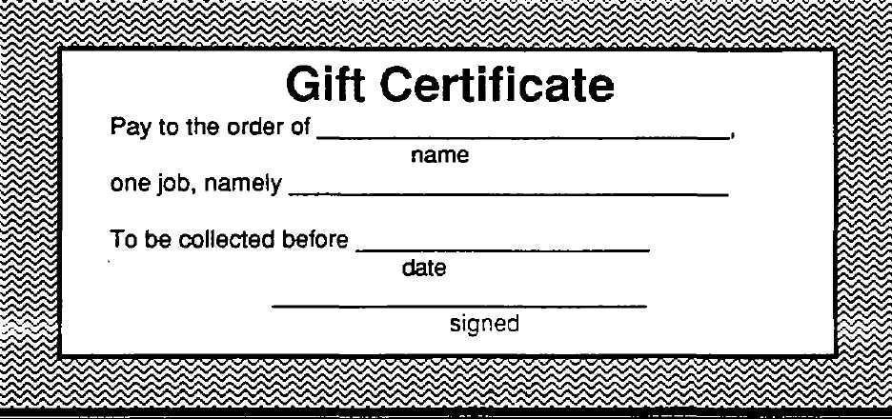

**Classroom Jobs**

Here are my classroom jobs for       (date/dates)

**Classroom Job:**

**Responsibility:**

**My Jobs at Home or How I Can Help**

Print this page, and sketch a picture of yourself doing one of your jobs at home.

**Sample Letter to Parent**

Dear Parent of       (Student),

Our class is becoming aware of the worth and dignity of all work. Can you help us with our career awareness unit? We want to make a chart of different kinds of workers, duties, and tools. We also hope some parents can come to school to tell about their work or hobby.

1. What is your job? Where do you work?

Mother:

Father:

2. What are some of your duties?

Mother:

Father:

3. Is there anything about your work which students would enjoy seeing e.g., uniforms, tools, products, raw materials, pictures, demonstrations)?

Mother:

Father:

4. Would you be able to come to school to tell our class about your work or hobby?

Mother:

Father:

5. Do you know of another person who might be able to tell the students about  
 his/her work or hobby? How might we contact him/her?

Mother:

Father:

**Sample Letter to Parent**

6. If you can come, please sign here, and tell us the specific days of the week and  
 times of day most convenient for you to come to school. We will contact you.

Mother:       (Days and Times)       (Phone)

Father:       (Days and Times)       (Phone)

Sincerely,

Teacher

**Sample Invitation Notice**

**The Vita! Link between School and the World of Work**

A selected group of students is studying career awareness. One of the requirements of this course is that each student invites a guest speaker to come to school and tell the class about his/her job or career. The student must introduce his/her speaker and write a follow up thank you note.

The objective of these lessons is not to get students to make career choices, but rather to help acquaint students with the wide variety of occupations that exist. We hope this will make their present schooling more relevant to their futures.

We look forward to meeting you and hearing about your job. Thank you for your willingness to participate in our program. Without your cooperation, this phase of our program could not exist.

Sincerely,

Teacher

School

**Sample Speaker Response Form**

Name:

Occupation:

Workplace address:

Contact Phone Number:

Do you need any special equipment for your visit?

Dates you would be available to be our guest speaker:

Times you would be available:

**Sample Guest Speaker Confirmation Letter**

Dear      ,

Thank you very much for your willingness to be a guest speaker. Without your cooperation, this phase of our program could not exist.

The objective of our guest speaker program is not to get students to make career choices. Rather, the goal is to help students realize everyone works, and that all useful work is honorable. We hope to acquaint them with the wide variety of occupations that exist and to make their present schooling more relevant to their futures.

Your company or business may have some pamphlets or materials it would provide for you to bring along. We would appreciate appropriate handouts. Please bring sample tools and equipment with which you use for children to view. If you wear a uniform or special clothing of any kind for your work (e.g., welding hood, nursing clothes, etc.), bring or wear the uniform/clothing if you can. Here are some suggestions about the kinds of things we would like to know:

What is your job title and job description?

What aptitudes or skills are important for your job?

What are working conditions like?

What are your fellow employees like?

Do you have to deal with the public? If so, would you care to comment on this?

If you are separated from people most of the time or working with things, how do you feel about that?

What do you consider the best points of your job? The worst?

Is your job personally rewarding or fulfilling? Do you recommend it as one of  
the alternatives students should consider?

You may want to touch upon the financial aspect. Do you consider the pay to  
be adequate, very good, or unsatisfactory?

**Sample Guest Speaker Confirmation Letter**

What is the outlook? Will this type of employment exist when these students  
enter the world of work?

What changes in equipment, automation, personnel, and training requirements have you experienced in the time you have been in this field?

What training is required (high school, college, apprenticeship, trade  
school)?

Is the field difficult to enter (union membership, professional school entrance  
quotas, etc.)?

We will be expecting you at       (time) on       (date). You will be speaking

to     -graders for       (amount of time) in Room       at       (location).

We look forward to your upcoming visit.

Sincerely,

Teacher

**Sample Thank You Letter**

April 18, 2015

Mr. David Martin

Marietta Astronautics Group

P.O. Box 179

Boise, ID 83706

Dear Mr. Martin:

Thank you so much for allowing Mr. Barns to speak to our career awareness class at Westgate about his work at Marietta Astronautics Group. His excellent communication skills and sincere interest in his career helped our students realize some of the possible opportunities available in their futures. Mr. Barns’ presentation was both enjoyable and informative.

Much of our career awareness program would not be possible without many wonderful and supportive people like Mr. Barns. We hope we can count on your continued support of our program. Please extend our appreciation to Mr. Barns.

Sincerely,

Teacher

**Thank You Certificate**

This type of certificate can be given to each guest speaker by the inviting student and teacher.

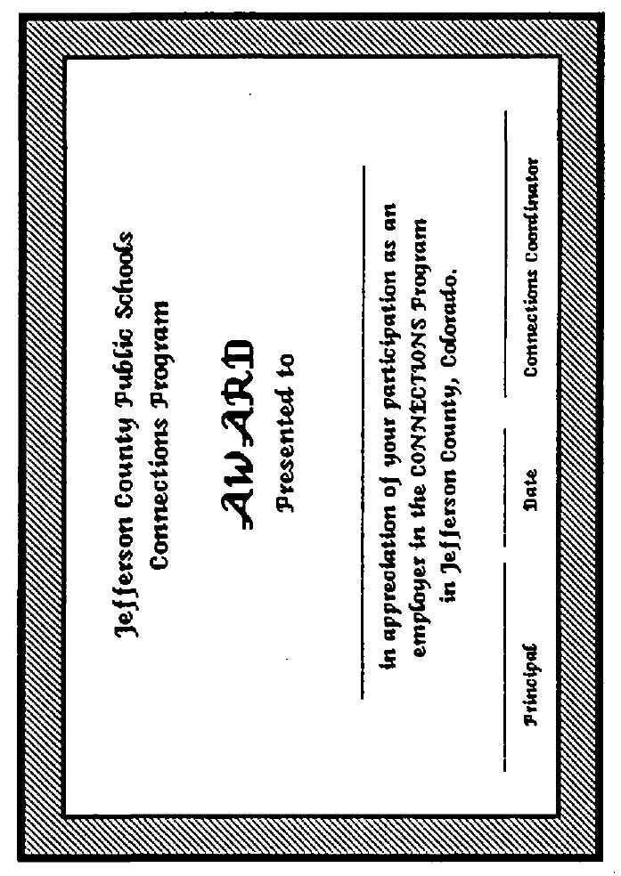

**Interview Form**

Name of Interviewee:

Name of Interviewer:

Date of Interview:

1. What is your name?

2. What is your occupation?

3. Where do you work?

4. What tools or equipment do you use?

5. Do you work indoors, outdoors, or both?

6. When did you decide to choose this career?

7. How did you happen to choose it?

9. What training do you have?

10. What are the main skills needed?

11. What did you learn in elementary school that you use in your work now?

12. What are your working hours?

13. How many vacation days do you have each year?

14. What are the main benefits of this career?

15. What do you like about your work?

16. What would you change about your work?

**20 Questions**

The following form can be used in interviewing guest speakers, workers you see on field, and neighbors or people in your town.

Remember, not everyone may wish to answer each question. Take as much information as they wish to share with you. Be sure to thank each person.

Name of Interviewee:

Name of Interviewer:

Date of Interview:

1. What is your job title?

2. Is your job in agriculture, industry, or is it a service?

3. What does your job involve?

4. What special training or experience did you need for your job?

5. How did you find your job?

6. Are there many people who have the same kind of job?

7. Do you need to wear any special clothing?

8. What special equipment do you need?

9. What are the dangerous parts of your job?

10. What do you like about your job?

11. What do you dislike about it?

12. Why did you take this job?

**20 Questions**

13. Can you find this kind of job in any part of the country?       Why or why not?

14. Can both men and women do this kind of work?       Why or why not?

15. Does your physical size matter in your work?

16. Does your age matter?

17. Do you think your salary is high enough for the job you do?       Why or why not?

18. What other benefits do you get besides salary?

19. Do you belong to a union?       Why or why not?

20. What other kinds of jobs could you have with your experience and training?

**Student Evaluation of Guest Speaker**

Check your answer.  
 **YES NO**

1. The speaker was interesting.

2. The speaker did a good job of describing    
his/her job and the tasks and responsibilities

involved.

3. The speaker showed the connection

between school studies and his/her career.

4. The speaker gave information about the    
 education and experience needed for a

career in his/her field.

5. The speaker brought in his/her “tools-of-the-

“trade”

6. The speaker talked in a way that I could

understand him/her easily.

7. The speaker allowed time for me to ask

questions of my own.

8. The speaker did a good job in answering

students' questions.

9. The speaker made me interested in his/her    
 career and made me want to find out more

about it.

10. I would like to hear this speaker again.

11. I would give this speaker a grade of \_\_\_\_\_.

**Field Trip Inventory**

Location:       Date:

Contact Person:       Title:

Address:       Telephone:

1. What can be seen or observed during a field trip to this business/industry?

2. How many students can tour at one time?

3. How much advance notice does the company prefer?

4. How many field trips per year would the company be willing to allow?

5. Are any safety devices required, such as safety glasses or hard hats?

If yes, does the company supply these?

6. Are printed materials available, which describe the business or industry that  
could prepare students in advance of the field trip?

How do we get those?

7. How much time is required for a typical field trip?

Comments:

**Keep Your Eyes Open!**

1. Did you see anyone working?

2. What were some of the people doing?

3. What are these workers called?

4. Were they working indoors or outdoors?

Alone, or with other people?

5. What kinds of machines or tools did you see?

      What were they used for?

6. Which person would you like to help for a day?

Why?

7. Which job do you think requires the most training or experience?

8. What are the advantages of the jobs you saw?

What are the disadvantages?

9. Could both men and women do these jobs?

10. What would happen if these jobs were eliminated?

11. How do you think these jobs will change 100 years from now?

**Field Trip Check-Up**

Name:

Grade:

Directions: Please answer each question with your honest response.

|  |  |  |  |
| --- | --- | --- | --- |
| **Study Trip Check-Up Questions** | **Yes** | **No** | **Sometimes** |
| Did I return permission slip and required money promptly? |  |  |  |
| Was I dressed appropriately? |  |  |  |
| Did I bring toys/unnecessary items on this field trip? |  |  |  |
| Did I bring any gum, food, or drink on the bus? |  |  |  |
| I thanked the bus driver. |  |  |  |
| I looked at the speaker while listening. |  |  |  |
| I looked at the speaker while listening. |  |  |  |
| Did I use appropriate language? |  |  |  |
| I thanked the tour guide. |  |  |  |
| Did I face front on the bus? |  |  |  |
| Did I keep my feet out of the bus aisles? |  |  |  |
| I asked intelligent questions. |  |  |  |
| Did I ask questions that were on topic? |  |  |  |
| Did I touch property belonging to the place of business? |  |  |  |

|  |  |  |  |
| --- | --- | --- | --- |
| **Study Trip Check-Up Questions** | **Yes** | **No** | **Sometimes** |
| Did I stand unless given permission to sit by the speaker? |  |  |  |
| Did I keep my hands to myself? |  |  |  |
| Did I talk too loudly to get someone’s  attention? |  |  |  |
| Was I polite to everyone? |  |  |  |
| Did I talk with friends while the  Speaker was talking? |  |  |  |
| Did I follow all directions given by the adults in charge? |  |  |  |

**My Career Contract**

I,      , will find out about the following career and participate in a career awareness experience. I will make an oral report to my class, which will be due following my career awareness experience. This report will tell about the career, place of work, skills needed, tools used, and how the career is helpful or important.

Career choice:

1. Before arriving at my job site, I will write ten questions to ask my community partner.

2. During my career awareness experience, I will observe and interview my community partner at work.

3. I agree to allow my community partner to evaluate my performance and behavior.

4. I will write a thank you note to my community partner within three days of my observation.

     

Student Signature Date

**My Career Agreement**

I,       will find out about the following career:      .

I will make a report/notebook/project (highlight your choice), which is due on      .

It will tell about the career, place of work, skills needed, tools used, and how the career is helpful or important. I will also choose two of the following

activities, and put them in a notebook:

(Highlight two choices)

1. Draw or find three pictures of services or products related to this career.

2. List five skills needed for this career. Write a paragraph telling which of these skills I am beginning to learn in school or at home.

3. Cut out and paste three newspaper want ads for this career into my notebook, *or* copy three advertisements from the telephone book’s yellow pages, which advertise people and services related to this career.

4. Interview a person with this career, and write up an interview sheet about the person.

     

Student Signature Date

     

Teacher Signature Date

**Career Awareness Experience**

**Evaluation Form**

Name:

The career I was interested in was:

The worker I interviewed was:

Write a brief description of the job you observed:

The things I would like about this job are:

The things I would not like about this job are:

If you had the opportunity to make a job choice again, would you do the same job, or would you try something different? Explain your answer below:

**Sample Employer Evaluation of**

**Job Shadowing Experience**

Dear \_\_\_\_\_\_\_\_\_\_\_\_\_\_\_\_\_\_\_\_\_\_\_\_\_\_\_\_\_\_\_\_\_\_\_\_\_\_\_,

In order to evaluate the success of the Job Shadowing Program as well as that of \_\_\_\_\_\_\_\_ \_\_\_\_\_\_\_\_\_\_\_\_\_\_\_\_'s potential job performance, would you please answer yes or no to the following questions about the student’s visit?

1. Did the student arrive on time?

2. Was the student well groomed? (Clean and neatly dressed)

3. Did the student introduce himself?

4. Was the student an interested observer?

5. If invited to do something, did student participate?

6. Did the student ask questions and/or make appropriate comments?

7. When it was time to leave, did the student thank you?

8. Have you received a personal thank you note from this student?

9. Would you be willing to have a Job Shadowing student from our school again?

Please add any suggestions or comments you may have in the space below. Thank you for taking time to answer these questions.

Very truly yours,

Teacher

**Reading-on-the-Go**

“Reading-on-the-Go” is the reading you do every day while you are on the go. Examples may include when you check the calendar, read a street sign, or use the door marked, “Exit.” Find 10 examples of “Reading-on-the-Go” while you are going through the day, and list them below.

1.

2.

3.

4.

5.

6.

7.

8.

9.

10.

**Restaurant Vocabulary**

|  |  |  |  |  |
| --- | --- | --- | --- | --- |
| Dot | Diced | Scald | Ground | Reduced |
| Course | Dessert | Entrée | Beat | Fold |
| Stewed | Tossed | Blended | Braised | Ala Carte |
| Appetizer | Beverage | Baked | Baste | Cubed |
| Breaded | Broiled | Browned | Dried | Fried |
| Mixed | Pared | Puree | Chilled | Chopped |
| Combine | Creamed | Crushed | Drained | Grilled |
| Frozen | Glazed | Grated | Kneaded | Measure |
| Preheated | Prepared | Poached | Sautéed | Halved |
| Mashed | Minced | Melted | Steamed | Toasted |
| Roasted | Whipped | Buttered | Flavored | Seasoned |
| Shredded | Extra | Spread | Spiced | Smoked |
| Sliced | Sifted | Simmered | Barbequed | Preserved |
| Quartered | Scalloped | Scrambled | Marinated | Tip/Gratuity |
| Helping | Included | Sandwich | Service | Side dish |
| Takeout |  |  |  |  |

Can you think of any others?

**Eating out Can be Educational**

You will need a menu to complete this worksheet.

1. The name of this restaurant is      .

2. Using your menu, order an entire meal. Choose:

An appetizer –

A main dish –

A beverage –

A dessert –

3. What is the most expensive item on this menu? Write the item and its cost.

Item:

Cost:

4. Menus use descriptive words to tell about their food. Find five descriptive words, such as “fresh,” “tasty,” or “delicious” in your menu:



5. What could you buy nine friends and yourself at this restaurant if you had only $10?

**Eating out Can be Educational**

6. Let's pretend you've just opened your own restaurant. Write you own menu  
 item. Include the name, a description, and the price.

Name:

Description:

Price:

7. What would you buy for nine friends and yourself if you had only $10?

8. Describe the atmosphere at your restaurant.

9. Describe the service at your restaurant.

10. For what three things would you want your restaurant to be known?



**Eating out Can be Educational**

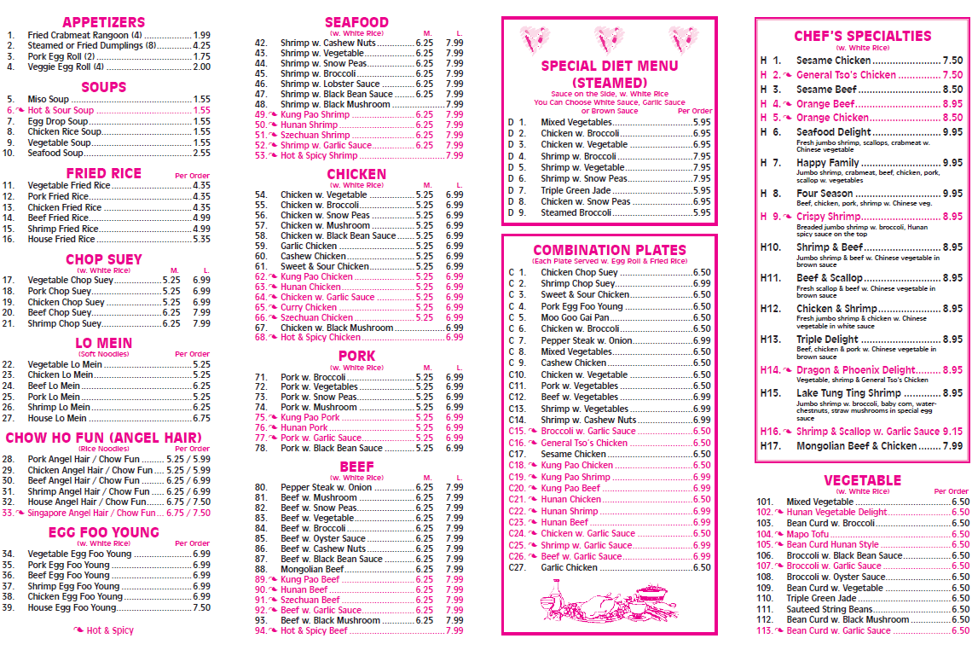

**On-the-Job Reading**

Can you think of when reading is required by these professionals?

Football Player?

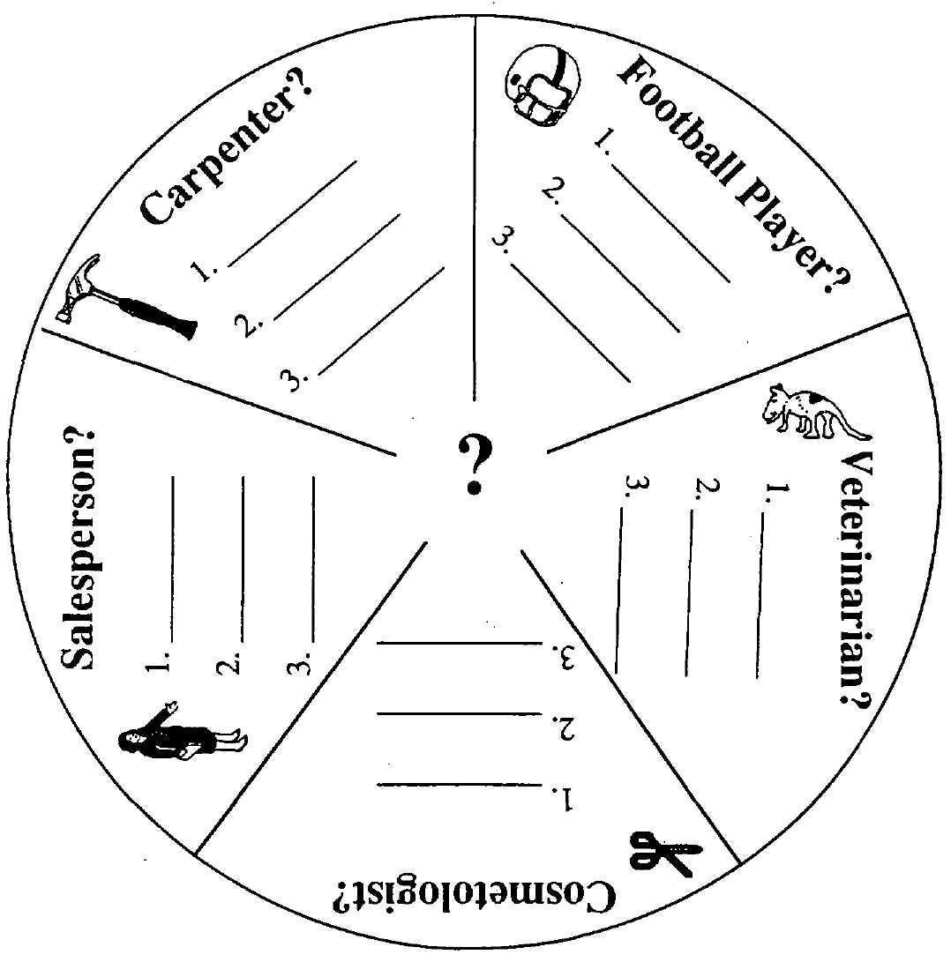



Veterinarian?



Cosmetologist?



Salesperson?



Carpenter?



**Getting Your Foot in the Door Cards**

|  |  |  |  |
| --- | --- | --- | --- |
| **Applications** | **Job Information** | **No Help Wanted** | **Part Time Help Wanted** |
| **RECEPTIONIST** | **Employment Office** | **APPLY AT OFFICE** | **Apply at Personnel Office** |
| **Help Wanted** | **Employment Agency** | **DIRECTOR OF PERSONNEL** | **NO UNAUTHORIZED PERSONS BEYOND THIS POINT** |
| **Apply Here** | **PERSONNEL OFFICE** | **Authorized Personnel Office** | **ALL VISITORS MUST REGISTER AT OFFICE** |
| **EMPLOYEES ONLY** | **PERSONNEL MANAGER** | **EQUAL OPPORTUNITY EMPLOYER** | **Applications Accepted from 11:00 A.M. to 3:00 P.M. Only** |

**The Breakfast Cereal Box**

Using your breakfast cereal box, complete the following:

1. List the name of your cereal and by whom it was made (brand).

2. What gimmick did the company use to sell this cereal?

3. On your cereal box, find and write all the adjectives that describe the cereal.

4. Put in order the main five ingredients of the cereal.

5. How many calories will be found in a 1-oz. serving of this cereal if you use skim milk?

6. Exchange your box with another student. How are these cereals different?

7. Support your reasons for the purchase of your cereal to your mother. Why should she by this cereal for you?

8. If you were to create a new cereal box what would it look like? Design your cereal box on a piece of paper.

**Reading Prescription Bottles**

1. How many pills are in the bottle?

2. Use a dictionary to find out what “authorization” means, and write the definition below.

3. Use a dictionary to find out what “required” means, and write the definition below.

4. According to this prescription for the person named on the bottle, how many pills should the person take each day?

5. What date was this prescription filled?

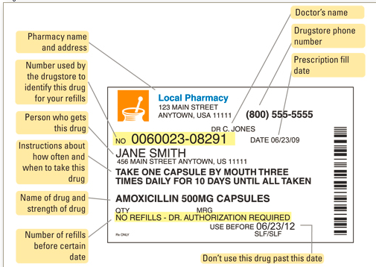

**Dangerous! Read Before Using!**

**Vocabulary:**

**Precautions –** safety steps to take ahead of time

**Medical –** a doctor's care

**Internal –** inside the body

**Caustic –** burning

**Induce** – start; make happen

**Corrosive** – eats away at things

**Vomiting** – throwing up

**Solutions** – water with something in it; in this case, water with amounts of cleaning fluid that can be poisonous if used incorrectly

**Quantities** – exact or specified amounts or measures

**Fatal** – deadly; can kill you

**External** – outside the body

**First aid** – things to do right away if someone is hurt or sick

**Physician** – doctor

**Immediately** – right away

**Dangerous! Read Before Using!**

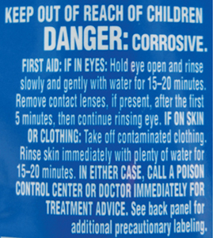

This is for information only and not for use in the treatment or management of an actual poison exposure. If you have an exposure, you should call your local emergency number (such as 911) or the National Poison Control Center at 1-800-222-1222.

### Home Care

Seek immediate medical help. Do NOT make a person throw up unless told to do so by poison control or a health care professional.

If the chemical was swallowed, immediately give the person water or milk, unless instructed otherwise by a health care provider. Do NOT give water or milk if the patient is having symptoms (such as vomiting, convulsions, or a decreased level of alertness) that make it hard to swallow.

If the person breathed in the poison, immediately move him or her to fresh air.

Answer the following questions:

1. Why are precautions needed for cleaning fluids?

2. What does *caustic* mean?

3. What does *corrosive* mean?

**Dangerous! Read Before Using!**

4. What do you think can happen if you get poison in your eyes?

5. What do you think can happen if you swallow cleaning fluid?

6. Where do you think this cleaning fluid should be stored? Why?

7. What is the first thing you should do if you get this cleaning fluid in your eyes?

8. Why shouldn’t you make someone throw up if the person has swallowed this cleaning fluid? What should you do, instead?

9. If you swallow this cleaning fluid or get it on your skin, what should you do first?

10. What phone number should be called for emergency information on what to do if someone has gotten any poison on their skin, in their mouths, in their eyes, or have swallowed it?

**“Direction” Words are Important**

Do you know the meaning of these words? Let’ see.

|  |  |  |  |
| --- | --- | --- | --- |
| color  draw  write | read  circle  mark | count  show  cut | find  open  print |
| paste  match  put | place  copy  close | choose  trace  underline | turn  hold  start |
| list  check  cross | follow  touch  sign | divide  fold  bend | measure  select  complete |

**Doing it in Order Makes a Difference!**

Peanut Butter Fudge

1 cup peanut butter 11/4 cup powdered sugar, sifted

1 cup corn syrup 1/4 cup cocoa

11/4 cup dry milk nuts (optional)

Blend peanut butter and corn syrup in large mixing bowl; add dry milk and 1 cup sugar. Add cocoa. Mix with wooden spoon, and then knead until smooth on pastry board lightly covered with remaining 1/4 cup sugar. Top with nuts if desired.

- - - - - - - - - - - - - - - - - - - - - - - - - - - - - - - - - - - - - - - - - - - - - - - - - - - - - - -

Read these directions silently as your teacher reads them aloud. Let’s be sure we understand what to do!

Class discussion questions:

1. What are the steps we need to follow to make our fudge?

2. What does *knead* mean? What are you to use in “kneading” this  
dough?

3. What does *optional* mean?

4. Why are ingredients listed before the directions?

5. How many people do you think can feed with this recipe?

6. What if you didn’t have any powdered milk? What could you use instead?

**Signs to Remember for Safety**

Place the number of the correct answer below each sign. Match the explanation with the signs.

1. This is not a stop sign, but you should come to a stop and look both ways  
before going on. If there is traffic approaching from either direction, you  
should wait for them to go by.

2. Follow this path on your bicycle.

3. There is a traffic signal ahead. A red light means to stop, and a green light lets you go through the intersection.

4. This is a school crossing. You cross the road here, but look both ways to be certain the cars all stop.

5. This is a stop sign. You must stop, and look in all directions. If there is no traffic, you can cross the street safely.

6. There is a railroad crossing ahead. Before you cross the tracks, you need to look both ways to make sure there is no train coming.

7. The big white “H” on a blue background means there is a hospital ahead.  
It also means that you should be especially alert for ambulances and  
other emergency vehicles.

8. This means you cannot turn left at this street. You either turn right, or go straight ahead. Anytime you see a diagonal line drawn through a sign, it means NOT to do what the symbol underneath the diagonal line shows.

C:\Users\vateacher\AppData\Local\Microsoft\Windows\Temporary Internet Files\Content.IE5\ZVX8RXCG\60px-Hospital_sign.svg[1].png   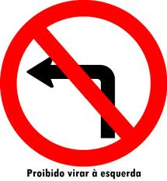

   

**Playground Rules for Safety**

**BOUNDARIES:** West - Sand pits and the ditch

North - Fence and trees near there

East - Edge of the blacktop for 1st & 2nd grades

South - Fence, but don’t go south of the building

1. Stay off the sidewalk; keep away from the buildings.

2. Stay off any fences or backstops.

3. Don’t climb or damage trees.

**LEAVING THE PLAYGROUND:**

1. Don’t leave the playground without asking permission. Children should notify the teacher on duty when he or she returns to the playground.
2. Teacher discretion as to allowing kids to go to lost and found, clinic, office, etc.
3. Equipment and coats should be brought out at the beginning of recess.
4. Don’t re-enter school without permission.

**EQUIPMENT:**

Swings: Slide:

1. One per swing 1. One at the top
2. Sit on swings 2. One on the ladder
3. Swing straight 3. Slide down on seat
4. No pushing 4. No jumping from slide or sliding down
5. Count-backs are allowed poles
6. Don’t play around swings
7. No jumping off swings Jump Ropes:
8. No climbing on the poles 1. Use on blacktop areas only
9. No ropes on the swings 2. Remind children of safe use of jump ropes

Monkey Bars: Balls:

1. Do not interfere with 1. Balls are to be used out in the fields, not  
   another person's climbing around equipment.
2. No ropes on the bars
3. No one around the bars unless they are using them

General:

1. No sand, snow, or rock throwing at all
2. Use the sand pits for playing in the sand
3. No baseballs on playground; softballs only
4. No skates or skateboards
5. No tackling games, including tackling in tag, football, soccer, etc. TOUCH football may be played.
6. No foul language
7. Return to classroom immediately when bell rings

**The Small Mall Directory**

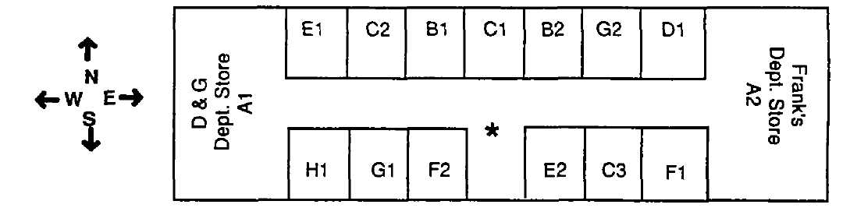

**YOU ARE HERE**

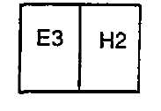

**General Jewelry Entertainment Gifts/Cards**

D&G A1 D. Allen's B1 Soundland C1 Benny's Gifts D1

Frank's A2 Remember! B2 Music Shop C2

Pianos Unlimited C3

**Women's Apparel Men's Apparel Books Food**

Bonnie's Clothes E1 Wilson's F1 Tree Leaf G1 Pizza Bay H1

Chasm E2 Tilden's F2 Mafdoans G2 Tacos, Etc. H2

Avantes E3

1. Name a store where you could buy a CD.

2. Name an ítem you might buy at Remember!

3. If you’re at Bonnie’s Clothes and you want to go to Frank’s Department Store, in which direction should you walk?

4. Which store is directly in front of you when you come through the entrance?

5. Can you buy plants at the store located at G1?

**The Small Mall Directory**

6. Which direction are you walking when you go from B2 to E2?

7. You want to eat tacos. Can you get them right in the mall? Explain.

**The T.V. Guide**

Answer the questions below after examining this TV listing carefully.

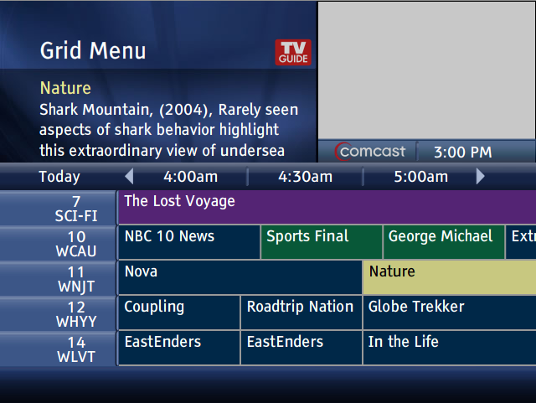

1. What time does Sports Final start?

2. What time does The Lost Voyage begin?

3. What channel do I need to have to be able to watch Globe Trekker?

4. Where can I find George Michael?

5. How long does the NBC news last?

**Working with the White Pages**

Below is a section of a telephone book. Use these names and numbers to answer the questions below.

PLEMONS L - PLOEN

Plemons Lynn 237-8950

Plese Robert 678-9904

Pleshko Don 555-3467

Pleshko Sammy 234-0984

Pless Fred 534-7887

Plesinger B 423-6534

Pletan Anne 454-0129

Pletcher M 788-7856

Pleuss Nancy 576-7943

Plewinski John 332-4477

Pliler Robert 758-0890

Ploent 478-1368

1. What phone number is listed just before M Pletcher?

2. Why does T Ploen follow Robert Pliler?

3. What is Fred Pless’ phone number?

4. Why do some names only have initials?

5. Why does Don Pleshko come before Sammy Pleshko?

6. Why are last names used first instead of first names?

**Newspaper Scavenger Hunt**

Find the following items in your newspaper. Put an “X” by the items you have found. Write the page number next to the item.

“X” Page Number

      a “Snoopy” comic strip

      the weather report

      a movie advertisement

      the lead story for the day

      the “Dear Abby” column

      an advertisement for a new car

      a food item

      an article about a famous person

      where jobs are listed

      where apartments for rent are listed

      where things like lawn mowers or

Furniture are advertised for sale

      where the stock market news is reported

      where international news (news about

other countries) is reported

      where letters from the newspapers’

readers are printed (letters to the editor)

      where people advertise that they’re

available to work

**Exploring Classified Ads #1**

**Babysitter Wanted!**

Reliable boy or girl to sit with 4-year old

4-7 p.m. Tuesday and Thursday evenings

Pay $1.50 per hour

Minimum age 10 years

Call 258-3729

**Wanted: Odd Jobs!**

Available after school from 3:30-5:00 p.m.

and anytime Saturday.

Yard work, cleaning, whatever.

Will work for $2 per hour.

Call Mike at 258-3499

Find your responses for the following questions in the ad for a babysitter.

1. What hours will you be working?

2. What days will you need to work?

3. How old do you have to be to apply for this job?

Find your responses for the following questions in the add for odd jobs.

1. Who placed the ad?

2. What hours and days is Mike available to work?

3. What kind of work is Mike willing to do?

**Exploring Classified Ads #2**

Classified ads are often used to let people know when a job is available or when a person is available to work. Sometimes the newspaper will have want ads that apply to youngsters.

**PIZZA DELIVERY DRIVER**PT, Sat/Sun 6pm - 10pm, Must have own car  
Call Dominoes 633-2440

1. Dominoes is looking for someone to deliver what?

2. Is the job full-time or part-time?

3. What shift will the person work?

4. What days of the week will the person work?

SALES PERSON, Full time  
Minimum 3 yrs exp. 2 refs.  
Apply in person, Furniture Mart  
124 E. Union Blvd

1. How much experience does this job require?

2. How many references must the applicant provide?

3. What will this person probably do?

4. Is this a full time or part time job?

DENNY'S RESTAURANT  
Now Hiring Cooks  
No exp necessary, FT/PT  
Call 275-0014 or apply at 3920 E. Bijou

1. What kind of worker does Denny’s want to hire?

2. Can a person work part time?

3. Can a person work full time?

4. How much experience does a person need for this job?

**Personal Letter Format**

Remember to *date* your letter.

The *Greeting* is Dear ,

The *Body* is the main section of a letter.

The *Closing* might be: *Yours, Yours Truly, Sincerely,* etc.

Sign your name in cursive.

**In a friendly letter:**

* Tell your reader news about yourself.
* Ask the reader what they have been doing.
* Write as if you are having a conversation with the reader.

**You may choose to:**

* Ask a friend about current activities/events.
* Ask about a friend's family.
* Tell about your own current activities/interests.
* Tell about your family.

**Where Does it Fit?**

Put the information below into its proper place on the letter form. (If completing this on the computer, the underlined field in which you type will increase and will continue to be underlined. Simply delete any unnecessary lines.)

     \_\_\_\_\_\_\_\_\_\_\_\_\_\_\_\_\_\_\_\_\_\_\_\_\_\_\_\_\_\_\_\_\_\_\_\_\_\_\_\_\_\_\_\_\_\_\_\_\_\_

\_\_\_\_\_\_\_\_\_\_\_\_\_\_\_\_\_\_\_\_\_\_\_\_\_\_\_\_\_\_\_\_\_\_\_\_\_\_\_\_\_\_\_\_\_\_\_\_\_\_\_\_\_\_\_\_\_

\_\_\_\_\_\_\_\_\_\_\_\_\_\_\_\_\_\_\_\_\_\_\_\_\_\_\_\_\_\_\_\_\_\_\_\_\_\_\_\_\_\_\_\_\_\_\_\_\_\_\_\_\_\_\_\_\_

\_\_\_\_\_\_\_\_\_\_\_\_\_\_\_\_\_\_\_\_\_\_\_\_\_\_\_\_\_\_\_\_\_\_\_\_\_\_\_\_\_\_\_\_\_\_\_\_\_\_\_\_\_\_\_\_\_

\_\_\_\_\_\_\_\_\_\_\_\_\_\_\_\_\_\_\_\_\_\_\_\_\_\_\_\_\_\_\_\_\_\_\_\_\_\_\_\_\_\_\_\_\_\_\_\_\_\_\_\_\_\_\_\_\_

     \_\_\_\_\_\_\_\_\_\_\_\_\_\_\_\_,

     \_\_\_\_\_\_\_\_\_\_\_\_\_\_\_\_

*Your friend, Tom November 4, 2015*

*I just received a raise! I wanted you to know that I can now afford to come visit you. I'm really excited about this chance to visit. See you soon!*

*Dear George,*

**Addressing Your Envelope**

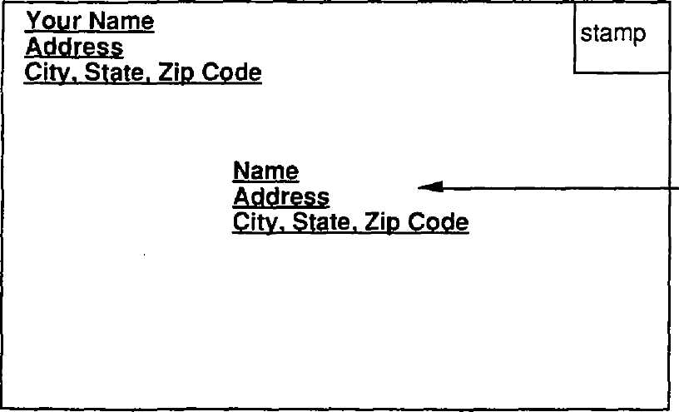

This is to whom you are sending the letter.

Remember, print or write neatly. The mail carrier must be able to read the address. Fill in all the lines below with the correct information.

Your letter is to be sent to:

3650 Chase Boulevard Frank Beal Moscow, ID 83843



**Writing a Letter of Request**



Now that you have a model for a letter of request, write your letter on a separate sheet of paper.

**Letter of Thanks**



“Clincher” closings say something very nice about the person you're thanking.

Now that you have a model for a letter of thanks, write your letter on a separate sheet of paper.

**The Invitation**

Sometimes, we write to announce a special event. We may want to invite people to a party. There are special pieces of information that must be included in an invitation:

* **Why** you are writing
* **Who** is doing the inviting
* **What** kind of event it is
* **When** it is taking place
* **Where** it is taking place

November 15, 2015

Dear Sandy,

Bob and I are having a party for Jason. The party will be next Friday, November 22nd at 8:00 pm at my house, 552 Sierra Drive.

We home you can come.

Regards,

Fred

Please R.S.V.P by November 20, 2015

**Who:** Bob and Fred

**What:** A surprise party for Jason

**When:** Next Friday at 8:00 p.m.

**Where:** Fred's house, 552 Sierra Drive.

Notice the letters **R.S.V.P.** at the bottom of the letter. R.S.V.P. is an abbreviation that means “please answer.” (Let us know whether or not you can come.) It is important to respond so that the party-giver is sure to have enough food and drink for everyone.

**How is a Postcard Different?**

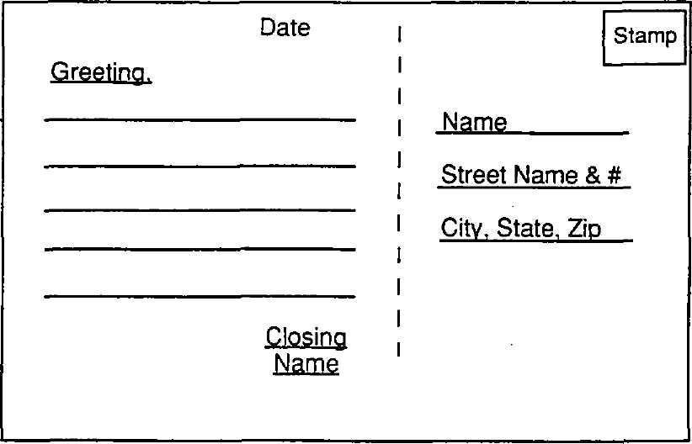

The *left side* is where you write your message.

The *right side* is where you write the name and address of the person to whom you are sending the postcard.

Now that you have a model for a postcard, write your own on a blank postcard or index card.

**Who has to Write?** 

Look at the picture to the right. What job does this man do?

What is this man doing that is part of his job?

Many professions require writing skills. Your team is to list as many jobs as you think of that require writing. Next to the job, list the specific respondsibilities that require writing.

The first one is completed for you.

Job/Occupation Writing is needed to:

|  |  |
| --- | --- |
| Surgeon/Doctor | Fill out patient records/prescriptions |
|  |  |
|  |  |
|  |  |
|  |  |
|  |  |
|  |  |

**Writing Notes**

Situations: Part 1

1. Tell your sister why you borrowed her sweater.

2. Tell your teacher why you were chewing gum.

3. Tell why you got in a fight at recess.

4. Tell why you were absent yesterday.

5. Tell your teacher why you have to miss school to visit your aunt.

6. Tell a friend what you are bringing to a party.

7. Tell why you cant stay overnight with a friend.

8. Tell why you were tardy for class.

9. Tell your dad why you need an increase in your allowance.

10. Tell why you want to take piano lessons.

**- - - - - - - - - - - - - - - - - - - - - - - - - - - - - - - - - - - - - - - - - - - - - - - - - - - - - - - - -**

Situations: Part 2

1. Write a note apologizing for bad behavior.

2. Write a note explaining why you missed school last week.

3. Write a note thanking your neighbor for feeding your dog while you were away.

4. Write a note giving directions to your house.

5. Write a note asking for someone's help.

6. Write a note explaining a change in plans for Saturday afternoon.

**Designing a Bulletin Board Notice**

Print this page to write a bulletin board notice explaining you are willing to do odd jobs for money.



**Taking Telephone Messages**

It is important to take good telephone messages for others as they are often important and personal. It is up to you to provide the other person with a clear message of the call, and to make sure you relay all the facts and information.

Here's a situation that needs a message:

Your mother's boss called while she was in the bathroom. The boss wants your mom to know that the 7 a.m. meeting for tomorrow has been cancelled, but that she is to bring all the accounts in, anyway. She is to call him if she has questions.

Print this page to be able to write the message for Mom.

**Telephone Message**

**Giving Directions**

In order to help someone get from one place to another, clear and simple directions are a must.

Information that helps a person get to where he is going without making any wrong turns includes street names, landmarks and approximate distances. You'll often want to draw a map to assist someone in following your directions.

Let's pretend that to get from your house to the library, you take Union two blocks north to 62nd St. Turn left, and follow 62nd until you can go no further (this will be Market Ave.). Turn left again, and travel five blocks until you reach a stop light (Baylor Blvd.). Make a right turn on Baylor for one block, and you will be at the library. The address is 1919 Baylor Blvd.

Print this page, and track your route on the map below. Show where you think the library is located.

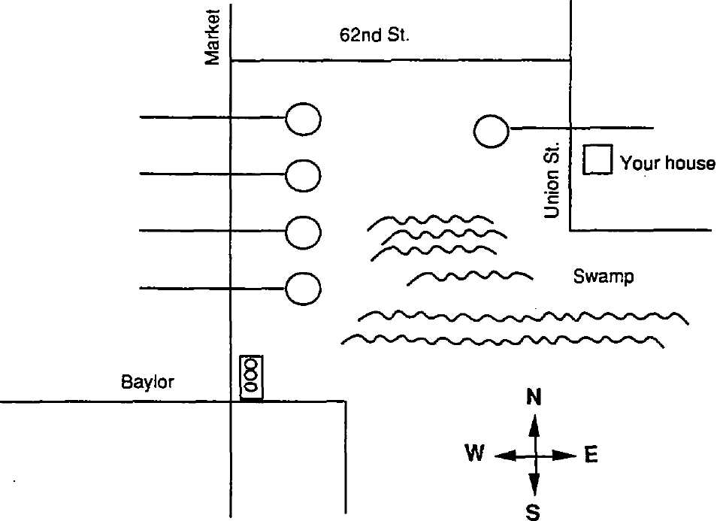

**Grouping and Categorizing**

**My Grocery List**

Directions: Following the move to your first apartment, you realize that your shelves and refrigerator are empty. Prepare a grocery list to fill your empty shelves. Keep in mind that you have offered to cook Sunday dinner for your family. You need to plan your meals for the week.

**FRUITS AND VEGETABLES**

1.

2.

3.

4.

**CANNED GOODS**

1.

2.

3.

4.

**MEATS**

1.

2.

3.

4.

**Grouping and Categorizing—My Grocery List**

**FROZEN FOODS**

1.

2.

3.

4.

**DAIRY PRODUCTS**

1.

2.

3.

4.

**BREADS**

1.

2.

3.

4.

**OTHER ITEMS**

1.

2.

3.

4.

**Organizing What You Hear**

Directions: When listening to a guest speaker, use the following form.

Guest Speaker:

Job Title:

1. Responsibilities

A.

B.

2. Qualifications

A.

B.

3. Why he/she chose this job

A.

B.

4. Training

A.

B.

5. Tools and Uniforms

A.

B.

**Organizing What You Hear**

6. Other jobs the speaker could do with these skills

A.

B.

7. Likes

A.

B.

8. Dislikes

A.

B.

9. Recommendations

A.

B.

10. Additional Comments

A.

B.

**Our Town**

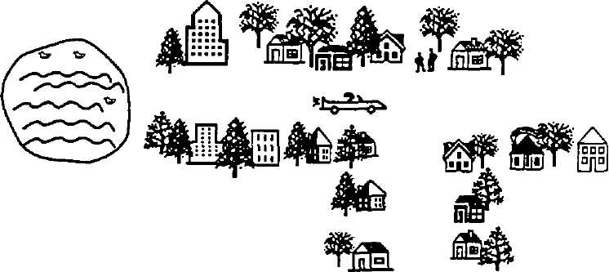

**MAKE A PAMPHLET TO ADVERTISE YOUR CITY/TOWN!**

1. Use a separate piece of paper to make the pamphlet.

2. Draw an interesting cover. Make it colorful.

3. Make a map of your city.

4. Describe your city:

* What's the population of your city? Who's the mayor? What's the weather like?
* Explain where people can go for recreation (parks, amusement parks, beaches, sailing, skiing, etc.)
* What types of entertainment is popular in your town?
* What are the names of the colleges or universities in your city?

5. Tell about any professional teams.

6. Make illustrations to go with you pamphlet.

7. Present your brochure to the class.

**School Information Cards**

Today's Date:

Name of School:

Name:       Date of Birth:

Address:

City:       State:       Zip Code:

Telephone Number:

Parents' or Guardians' Names:

Mother:

Father:

Parents' or Guardians' Work Telephone Numbers:

Mother:

Father:

Name and Phone Number of Person to Call in Case of Emergency:

**Sample Employment Application Form**

* **PLEASE PRINT ALL INFORMATION REQUESTED, EXCEPT SIGNATURE.**
* **THIS IS AN APPLICATION FOR EMPLOYMENT.**
* **APPLICANTS MAY BE TESTED FOR ILLEGAL DRUGS.**
* **PLEASE COMPLETE PAGES 1-4.**

DATE:

NAME:

Last First Middle (Maiden)

Present address:

Number/Street City State Zip Code

How long at this residence:       Social Security No. XXX – XX – XXXX

Telephone (    )   -

If under 18, please list age:

Position applied for (1)       and salary desired (2)

Days/hours available to work: No Preference

Monday       Thursday

Tuesday       Friday

Wednesday       Saturday

Sunday

Employment desired:  Full-time  Part-time  Either

When available for work?

**Sample Employment Application Form**

|  |  |  |  |  |
| --- | --- | --- | --- | --- |
| **Type of School** | **Name of School** | **Location**  **(Complete mailing address)** | **Number of Years Completed** | **Major & Degree** |
| **High School** |  |  |  |  |
|  |  |  |  |  |
| **College or University** |  |  |  |  |
|  |  |  |  |  |
| **Business or Trade School** |  |  |  |  |
|  |  |  |  |  |
| **Professional School** |  |  |  |  |

Have you ever been convicted of a crime?  NO  YES

If yes, explain below the number of conviction(s), nature of offense(s) leading to conviction(s), how recently such offense(s) was/were committed, sentence(s) imposed, and type(s) of rehabilitation.

**Vocabulary for Math**

|  |  |  |  |  |
| --- | --- | --- | --- | --- |
| **Time** | **Measurement** | **Money** | **Order** | **Math Concepts** |
| After | Height | Bill | Above | As many as |
| Eighth | Highest | Coin | Count | Between |
| first | Largest | Check | Empty set | Closed |
| Hourglass | Longer | Wallet | Five | Different |
| Stopwatch | Low | Paycheck | Fewer | Add or addition |
| Pendulum | Matching | Deposit | Nearer to | Multiply or times |
| Metronome | Yardstick | Price | Less than | Numerator |
| Send | Yard | Vault | Greater than | Denominator |
| Sixth | Quart | Cash | Order of operation | Complete |
| third | Ounce | Change | Below | Left |
| Before | Shape | Billfold |  | More |
| Fifth | Shortest | Save |  | Number |
| Fourth | Smaller | Bankbook |  | Open |
| Sundial | Taller | Receipt |  | Pair |
| Clock | Weight | Combination |  | Right |
| Watch | Meter |  |  | Same |
| Ninth | Pound |  |  | Series |
| Seventh | Scale |  |  | Top or bottom |
| Tenth | Measure |  |  | Number line |
|  | Ruler |  |  | Subtract |
|  | Foot |  |  | Divide |
|  | Mile |  |  | Sum |
|  | Pint |  |  | Degree |
|  | Shorter |  |  |  |
|  | Size |  |  |  |
|  | Smallest |  |  |  |
|  | Tallest |  |  |  |
|  | Inch |  |  |  |
|  | Liter |  |  |  |
|  | Gallon |  |  |  |

**Why Take More Math?**

|  |  |
| --- | --- |
| **YOU say…** | **Consider the reality that…** |
| I don’t like math. | Math is important in all areas of work. |
| I don’t do well with math. | Most people, even though who go into math-related careers, were not straight-A students in math. |
| It will hurt my grade average. | A well-rounded preparation is more important than your grade average. Not taking math will close the door to many careers. |
| I don’t like the teacher. | We all have our preference in teachers. If you don’t understand his/her explanation, form a study group to work with you. |
| I’m not going to need it anyway. | The average student in school today will work for over 20 years, whether male or female. You’ll lose out on higher pay if you don’t have a math background. |
| It’s boring. | One of the chief reasons students find math boring is that they lack confidence in their abilities. You seem to be able to do it, now you have to convince yourself that you can’t do it. |
| My mother / sister / friend didn’t need math. | Not everybody uses a lot of math, but more people are needing more math to do their work. You’ll increase your chances of having more job opportunities if you stay in math. |
| I feel dumb in math class. | It is awful to fee dumb. Find ways to help yourself feel more confident. Form a study group, or ask for some extra help. |
| I don’t want to be a nuclear physicist or anything like that. | Many career require a math background, and career opportunities will be increased by taking more math classes. |

**Planning Ahead**

BILLS, BILLS, BILLS!

Read the list of bills. In the blank next to the bill, write “M” if it is a “monthly” bill. Write “N” if it is a “now-and-then” bill.

      1. telephone       11. gas

      2. refrigerator       12. electricity

      3. dentist bill       13. school supplies

      4. television       14. rent or house payment

      5. food       15. gift for Grandma's birthday

      6. car repairs       16. insurance

      7. newspaper       17. field trips

      8. shirt       18. video rental

      9. bicycle       19. water and sewage

      10. trash       20. tickets to rodeo



**Money Manipulation**

**Adding Money**

$ .75 When adding money, you must use the

+ . 49 dollar sign and the decimal point in order

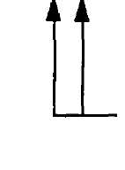

-The decimal point belongs between the dollar and the cents.

$ 5.06 $ 9.28 $ 7.66 $ 9.72

+ 9.28 + 7.91 + 4.13 + 5.15

$ 8.85 $ 8.38 $ 7.41 $ 6.70

+ 1.00 + 6.65 + 9.34 + 4.14

**Money Manipulation**

**Subtracting Money**

Don’t forget to line up the decimal point and use the dollar amount in your answer.

$ 9.22 $ 8.79 $ 7.44 $ 9.72

- 2.99 - 5.35 - 1.62 - 6.45

$ 8.91 $ 2.95 $ 8.94 $ 6.70

- 6.31 - 2.38 - 1.39 - 2.34

**Money Manipulation**

**Change, Please**

1. Randy bought a 55-cent candy bar. He gave the clerk at the Jiffy-Mart a $1 bill. The tax on the candy bar was four cents. How much change should Randy get back?

2. Angie works at the FLAV-OR-FREEZ. A customer bought a pint of ice- cream for $1.26 (tax included) and gave her a $10 bill. What change should she give to the customer?

3. Mary Jo's mother went to the grocery store and made purchases totaling $38.52 (tax included). She gave the cashier a $50 bill. What change should she get back?

4. Roni bought a video game cartridge that was marked “SALE: $5 off original price.” The original price was $23.95, and the tax on the reduced price will be $.95. Roni has two $10 bills. Does she have enough money to buy the game cartridge?

**Money Manipulation**

**Multiplying Money**

When multiplying money, remember to include the dollar signs.

$ 6.10 $ 9.50 $ 5.31 $ 9.71

x 1 x 2 x 2 x 8

$ 4.68 $ 6.75 $ 9.32 $ 6.14

x 8 x 0 x 9 x 2

$ 2.85 $ 3.47 $ 1.46 $ 5.22

x 2 x 6 x 6 x 5

**Money Manipulation**

**Dividing Money**

|  |  |
| --- | --- |
| $ 2.55 ÷ 5  Answer: | $ 9.20 ÷ 8  Answer: |
| $ 6.27 ÷ 3  Answer: | $ 5.39 ÷ 7  Answer: |
| $ 8.88 ÷ 2  Answer: | $ 4.41 ÷ 9  Answer: |

**Money Manipulation**

**Estimating Dollar Amounts**

**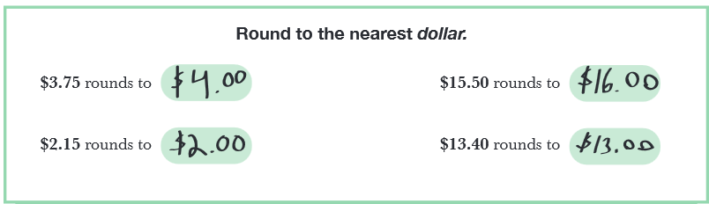**

1. $4.75 rounds to
2. $0.55 rounds to
3. $1.25 rounds to
4. $ 7.34 rounds to
5. $95.50 rounds to
6. $13.43 rounds to
7. $0.15 rounds to
8. $ 99.75 rounds to

**Money Manipulation**

**Wages Earned**

1. An automotive parts assembler earns $10 for each hour worked. The assembler worked only 20 hours last week. How much was the pay?

2. Judy Jones acted a role in a play that ran on Broadway for 12 weeks. The salary for this actress was $1,000 per week. How much did she earn?

3. A machine tool operator earns $100 for each hour worked. She earns time-and-a-half for any hours she works over eight hours in a day. If she works an extra hour one day, what would she be paid for that hour?

4. Here's a special problem! The owner of an automotive paint shop charges $200 to paint a car. Last week, 22 cars were painted in the shop. The owner pays the assistant $300 per week. The paint for 22 cars cost $600. The owner's overhead for this part of the business was $3,400. What was the owner's profit on the painting of cars?

**Divide and Decide #1**

Look in the grocery ad section of your newspaper. Look for ads in the products described in each problem below. Cut out, and paste the ads showing the prices you used to solve each problem on another sheet of paper.

1. If one dozen eggs will serve six people, how much is the cost per person?

Price for one dozen eggs:       Math problem (use space below):

Answer:

2. If one pound of hamburger serves three people, what will one serving cost?

Price for one pound of hamburger:       Math problem (use space below):

Answer:

3. If a five-pound roast serves eight people, what will one serving cost?

Price for a five-pound roast:       Math problem (use space below):

Answer:

**Divide and Decide #1**

4. If a pie serves five people, what will one serving cost?

Price per pie:       Math problem (use space below):

Answer:

5. If a small box of rice has eight servings, what will one serving cost?

Price per box:       Math problem (use space below):

Answer:

**Divide and Decide #2**

Look in the grocery ad section of your newspaper. Look in newspaper ads for the products described. Cut out and paste the ads showing the prices you used for each problem on another sheet of paper.

1. One quart of milk has enough for four large glasses. How much would one glass of milk cost?

Price of milk:       Math problem (use space below):

Answer:

2. If a quart of ice-cream will serve six people, how much would each serving cost?

Price for ice cream:       Math problem (use space below):

Answer:

3. If two pounds of chicken will serve three people, how much will each serving cost?

Price for chicken:       Math problem (use space below):

Answer:

**Divide and Decide #2**

4. If a can of vegetables has two servings, how much will one serving cost?

Price for a can of vegetables:       Math problem (use space below):

Answer:

5. If a cake serves seven people, how much will each serving cost?

Price of cake:       Math problem (use space below):

Answer:

6. If six loaves of bread use five cups of flour each, how much will twelve loaves use, and what will it cost?

Price of flour:       Math problem (use space below):

Answer:

**Can We Afford to Eat Out?**

First, decide what you would like to eat for a day. Plan your menu, and write down your choices for breakfast, lunch, and dinner.

When you have written the items for each meal and cost, total the daily cost of eating out at a restaurant on a *daily basis* for one week.

**Breakfast Cost Lunch Cost Dinner Cost**

|  |  |  |  |  |  |
| --- | --- | --- | --- | --- | --- |
|  |  |  |  |  |  |

Average Daily Cost:

Weekly Cost:

(7 x daily)

Surprise!

Did you remember to tip the waiter/waitress?

**Hunt and Find**

Movies are exciting, but tickets to see a movie can be expensive. There are some ways to get bargains when you want to go to the movies. One way is to choose a double feature and see two movies for the price of one. If you or someone with you is under 12 years old, you can often get a special price. In addition, some theaters have lower, matinee prices early in the day.

One way you can find out about prices is to look at the movie listings in the newspaper. The listings also show the times the movies start at each theater. Take a look at the movie section in your newspaper.

1. How much more does it cost an adult to see a movie after 5:00 p.m. than before 5:00 p.m.?

2. If you are under 12 years old, how much would it cost you to see a movie…

a**.** after 5 p.m.? $

b. before 5 p.m.? $

c. Which is the best buy?

3. Suppose your parents took you to see a movie.

a.How much would it cost them after 5 p.m.? $

b. How much could they save before 5 p.m.? $

c. Which is the best buy?

4. Suppose your parents drop you off to see the double feature at 3:45 p.m.

a. What time should they pick you up?

b. How long will you be at the movies?

c. What will be the cost of being able to see both movies?

**Hunt and Find**

5. Make a list of all the movies you can remember seeing the last year. Try to figure out about how much money you spent on tickets for those movies.

Movie:

Movie:

Movie:

Movie:

Movie:

Estimated total cost of all movies seen in the last year: $

**Planning a Party**

Guest List

Jeff C. Juanita G.

Julie E. Anthony B.

Andy R. Paul S.

Everybody loves a party, but parties don’t just happen. They take a lot of planning. For this pizza party, Janet had to figure out how many slices of pizza each person would eat, and how many glasses of punch they would drink. Then, she had to decide how many pizzas to order and how much punch to buy.

Janet didn’t want to waste her money. She had to decide whether to buy more small pizzas, or fewer larger ones. She had to figure out whether it would be better to buy small cans of punch or the larger quart size. That’s a lot to figure out.

**Come to a Pizza Party**

*Pizza and punch*

*All you can eat.*

*Games and prizes*

*Won’t it be neat?*

WHO: All invited

WHEN: June 17th from 3:45 – 6:00 p.m . MST

WHERE : 174 Garnet Gold Rush Street

**Come to a Pizza Party**

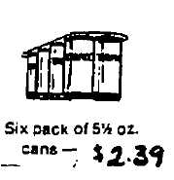

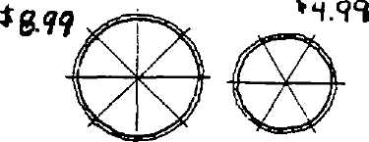

You can do your math work on another sheet of paper, but write your answers in the spaces below.

1. If Janet and her seven friends eat three slices of pizza each, what is the total number of slices they will eat?

2. Suppose Janet decides to order the large pizzas.

a. How many will she need? $

b. How much will they cost? $

3. Suppose Janet decides to order the small pizzas.

a. How many will she need?

b. How much will they cost? $

4. If each of the guests and Janet drink two 5 ½ oz. cans of punch…

a. How many ounces of punch will they drink altogether?

b. How many six-packs will Janet have to buy?

c. How many cans will be left over?

d. How much will the punch cost? $

**Come to a Pizza Party**

5. What is the better deal—large pizzas or small pizzas?

Why?

**Riding High**

Speed up and down the Dragon Roller Coaster! Ride into the sky on the giant Ferris Wheel! There's fun for everyone at Swanson’s!

When you go to an amusement park like Swanson’s, you don't usually pay for each ride as you go. You buy a book of tickets and use the tickets to pay for the rides. Sometimes you get more for your money if you buy a bigger book of tickets; sometimes you don't. With a little math, you can figure out the best deal.

Some rides require only two or three tickets, and some require as many as five. One problem withusing ticket books is that you may not realize how much money each ride is costing you. A little more math will help you plan your spending.



|  |  |  |  |
| --- | --- | --- | --- |
|  | **Number of** |  | **Number of** |
| **Ride** | **Tickets** | **Ride** | **Tickets** |
| Astroliner | **5** | House of Mirrors | **3** |
| Auto Scooter | **5** | Monster Mouse | **4** |
| Bumper Cars | **5** | Old Mill | **4** |
| Carousel | **2** | Over-the-Top | **4** |
| Casino | **4** | Rock-O-Plane | **4** |
| Caterpillar | **3** | Rotor | **4** |
| Derby Racer | **4** | Round Up | **4** |
| Dragon Coaster | **5** | Scrambler | **3** |
| Ferris Wheel | **3** | Sensavision | **5** |
| Flying Bobs | **4** | Spider | **4** |
| Flying Scooter | **3** | Tilt-A-Whirl | **3** |
| Flying Witch | **4** | Twister | **3** |
| Fun House | **4** | Whip . | **2** |
| Grand Prix | **5** | YoYo | **4** |
| Himalaya | **4** | Zyklon | **4** |

**Riding High**

1. What is the cost per ticket if you buy…

a. the $4 book of tickets?       per ticket

b. the $7 book?       per ticket

c. the $10 book?       per ticket

2. Suppose you and two friends all want to ride the Auto Scooter, the Grand Prix, the Ferris Wheel, and the Rock-O-Plane.

a. How many tickets will you need?

b. If you bought a book of 10 tickets, how many tickets will be left over?

3. Ask a friend to ride with you on the Caterpillar and the Grand Prix. How many tickets will the two of you need?

4. If you buy the $4 book or the $7 book of tickets, what is the real cost in dollars and cents to ride…

a. the Bumper Cars?

b. the YoYo?

c. the Caterpillar?

d. the Carousel?

5. Choose your three favorite rides. How much money would it cost to ride all of them?

a. Ride:

b. Ride:

c. Ride:

Total cost to ride all five favorite rides:

**Let’s Pretend**

Look for car ads in the newspaper. Find the names and prices of three different kinds of cars, and write them in the spaces on the worksheet. Then, choose three more cars, and repeat the process.

|  |  |  |  |
| --- | --- | --- | --- |
| **Name and Price**  **of Car** | **Name and Price**  **of Car** | **Name and Price**  **of Car** | **Name and Price**  **of Car** |
| **What is the average cost of the three cars?** | **What is the difference between the highest priced and lowest priced cars?** | **What is the difference in price between the two highest priced cars?** | **What is the difference between the lower priced cars?** |

|  |  |  |  |
| --- | --- | --- | --- |
| **Name and Price**  **of Car** | **Name and Price**  **of Car** | **Name and Price**  **of Car** | **Name and Price**  **of Car** |
| **What is the average cost of the three cars?** | **What is the difference between the highest priced and lowest priced cars?** | **What is the difference in price between the two highest priced cars?** | **What is the difference between the lower priced cars?** |

**Let's Pretend Questionnaire**

**What's the Best Car for You?**

1. At what age do you think you will buy your first car?

2. Why?

3. What makes your choices the best car for you?

4. How would you pay for your special car?

5. If you could afford $200.00 a month for a car payment, how long would it take you to pay for your car?

6. How many people would be riding in this car?

7. Let's pretend you need to find out what the insurance would cost for this car each month.

a. Who will you ask?

b. What would the insurance cost?

8. Estimate how many miles you think you would drive each week.

9. How much does a gallon of gas cost?

10. How many miles will your car go with each gallon of gas?

11. Estimate how much gas you would use each week.

a. How much would that cost?

12. Will you be able to afford this choice?

a. If not, what is your second choice?

**Figure the Percent**

Find newspaper or catalog ads for clothing. Pick out one ad for each of these three items. Calculate the cost of these items at the different discount prices listed to the left.

|  |  |  |  |
| --- | --- | --- | --- |
|  | **Jackets**  **(Regular Price)** | **Pants**  **(Regular Price)** | **Shoes**  **(Regular Price)** |
| **Regular Price** |  |  |  |
| **Figure the cost 50% off** |  |  |  |
| **Figure the cost**  **25% off** |  |  |  |
| **Figure the cost**  **10 % off** |  |  |  |

**Let's Go Shopping #1**

The super shopper always looks for the very best buy. That sometimes means buying the “right” size to get the best price. Which of these is the better buy? Highlight your choices.

FRUIT-O’S Breakfast Cereal

12-oz. box for $1.20

or

1-lb. box for $1.49

Almondo Candy Pieces

1 for $.10

or

3 for $.25

Head of Lettuce

1 head for $.79

or

3 heads for $2.00

SUNSHINE O.J.

6-oz. can for $.62

or

12-oz. can for $.99

**Let’s Go Shopping #2**

Write the brand name and cost of each item. You many need to do some calculating.

|  |  |  |  |
| --- | --- | --- | --- |
| 2 half-gallons of milk | 1 loaf of bread | 3-dozen eggs | 4 lbs. fresh apples |
| 5 pounds of ham | 3 cans of vegetables | 6 cans of frozen juice | 3 lbs. of hamburger |
| 2 half-gallons of ice-cream | 1 pound of butter | 2 pounds of bacon | 3 lbs. of chicken |
| 6 cans of dog or cat food | 1 16-oz. bottle of salad dressing | 5-lb. bag of sugar | 10 lbs. of flour |

**Let’s Go Shopping #3**

Check the grocery ad section of the newspaper. Look for three store ads. Look at the items listed, and write the cost of each item from Store # 1, then Store # 2, and then Store # 3. Compare store prices for each item. Using the number of the store, write that number in the more/less/same columns to the far right. Compare same brands.

|  |  |  |  |  |  |
| --- | --- | --- | --- | --- | --- |
| **Grocery Item** | **Store Ad #1** | **Store Ad #2** | **More** | **Less** | **Same** |
| Flour, 5 lbs. |  |  |  |  |  |
| Eggs, 1 doz. |  |  |  |  |  |
| Sugar, 5 lbs. |  |  |  |  |  |
| Tomatoes, 1 lb. |  |  |  |  |  |
| Potatoes, 1 lb. |  |  |  |  |  |
| Ice-cream, 1 gal. |  |  |  |  |  |
| Bananas, 1 lb. |  |  |  |  |  |
| Apples, 2 lbs. |  |  |  |  |  |
| Coffee, 2 lbs. |  |  |  |  |  |
| Milk, ½-gal. |  |  |  |  |  |
| Hamburger, 5 lbs. |  |  |  |  |  |
| Chicken legs, 3 lbs. |  |  |  |  |  |
| Frozen orange juice,  1 12-oz. can |  |  |  |  |  |
| Dr. Pepper, 6-pk. |  |  |  |  |  |
| Fresh carrots, 1 lb. |  |  |  |  |  |

**Saving for What You Want #1**

**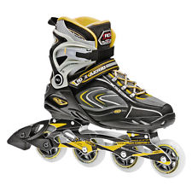**

**Sale $125.00**

**Regular $195.00**

Here it is—a sale on the rollerblade skates you've been saving for! The sale will be over on June 15th, and it is now May 23rd. The question on your mind—can you get the money in time?

You've been keeping a record of the money you've saved. Now is the time to look at that record and figure out if you can make it by June 15th. So far, you've saved $60.50 from your weekly allowance and from baby-sitting. You're expecting a birthday check from your grandmother, and the Darby family may hire you again for more baby-sitting or lawn care. Can you get the money you need before the sale ends?

Savings Record:

|  |  |  |  |
| --- | --- | --- | --- |
| **Date** | **Item** | **Amount** | **Cumulative Total** |
| May 1  May 8 | Allowance  Allowance | $10.00  $10.00 | $10.00  $10.00 |
| May 10 | Babysitting 3 hrs. at $5.00 per hour | $15.00 | $35.00 |
| May 15 | Allowance | $10.00 | $45.00 |
| May 18 | Babysitting - 7 hrs. at $5.00per hour | $35.00 | $80.00 |
| May 22 | Allowance | $10.00 | $90.00 |
| May 23 | Babysitting - 4 hrs. at $5.00 per hour | $20.00 | $110.00 |
|  |  | Subtotal | $110.00 |
|  |  |  |  |
|  |  |  |  |
|  |  | New Subtotal |  |
|  |  | Final Total |  |

**Saving for What You Want #2**

When you're saving up to buy something, you have to figure in other costs such as taxes. Suppose the sales tax in your town is 7%.

1. What is the sales price of the skates?

2. How much money will you pay in sales tax?

Math Hint:Multiply the sale price of the skates by .07 and round off to the nearest whole cent.

3. What will the total cost of the skates really be?

4. How much more money do you need to save to buy the skates?

On May 25th, your grandmother sends you a birthday check for $25. Enter this amount on the saving record.

5. Now, how much do you have toward the skates?

6. How much more do you need?

Look at the savings record. You'll see that you have been getting an allowance exactly every seven days. Get a calendar, and figure out how many more allowances you will get before June 15th. Enter those allowances on your record.

7. How much do you now have toward the skates?

8. How much more will you need?

Are you saving for something you really want? Make a savings record like the one on your worksheet. Use it to plan how you will save the money you need. Write your plan.

9. How long will it be before you have enough money?

See below for an extra credit task.

**Saving for What You Want #2**

Watch the ads for sales on five things you would like to have.

1. Figure out how much money each thing will cost if you include sales tax.

2. If any of the items have to be sent to your home, how much more will they then cost?

3. If you buy these things at regular prices, what is the total cost of each, including sales tax and shipping costs?

**Money Business #1**

**Place a check next to the correct answer.**

1. When we put money in a bank, it is called a…

loan

check

withdrawal

deposit

2. One service NOT offered by a bank is…

loan

a checking account

a savings account

selling toys

3. When we take money from our bank account it is called a…

withdrawal

loan

deposit

purchase

4. When we borrow money from a bank, it is called a…

loan

payment

trade

withdrawal

**Money Business #1**

5. A service offered by a bank is…

trading something you have for money

selling postage stamps

keeping money for people

selling envelopes

6. Money in a savings account earns…

checks

deposit slip

interest

application card

**Money Business #2**

**Place a check next to the correct answer.**

1. Which one of these is a money substitute?

$3.25

a ten-dollar bill

a bill from a store

a credit card

2. Which one of these is a money substitute?

a quarter

three dollar bills

a traveler’s check

a grocery sales slip

3. Which one of these is not a money substitute?

a bill from a store

a personal check

a traveler’s check

a credit card

**Money Business #2**

4. In order to write a check, you should have…

credit card

money in a checking account

no money anywhere

postage stamps

5. Traveler's checks cannot be exchanged for money without your second…

signature

ten-dollar bill

passbook

withdrawal slip

**Wall Street**

**SAMPLE STOCK UPDATE SHEET**

|  |  |  |  |  |
| --- | --- | --- | --- | --- |
| **Stock Name** | **Current Price** | **+ or -** | **# of Shares** | **Total** |
|  |  |  |  |  |
|  |  |  |  |  |
|  |  |  |  |  |
|  |  |  |  |  |
|  |  |  |  |  |
|  |  |  |  |  |
|  |  |  |  |  |
|  |  |  |  |  |
|  |  |  |  |  |
|  |  |  |  |  |
|  |  |  |  |  |
|  |  |  |  |  |
|  |  |  |  |  |
|  |  |  |  |  |
|  |  |  |  |  |
|  |  |  |  |  |

**Following a Recipe**

Did you ever think about how much math you do when you follow a recipe? You have to measure the ingredients. That's math. Sometimes, you have to double the recipe to make more. That's math. You have to eat the cookies. That's fun!

Getting ready:

Set the oven temperature to 375 degrees. Grease the cookie sheets well.

Oatmeal Cookies

This recipe makes a batch of 21 cookies.

1 cup flour 1 cup quick cooking rolled oats

1 Teaspoon baking powder 1 cup light brown sugar

½ Teaspoon Salt ¼ cup vegetable oil

1 Teaspoon cinnamon ¼ cup milk

1 Teaspoon ginger 1 egg

Make the cookie batter:

1. Get a large mixing bowl. Measure the flour, baking powder, salt and the two spices in a large bowl.

2. Measure the rolled oats (be sure to have quick-cooking oats, not instant oatmeal). Pour the oats into the flour, and stir with a mixing spoon.

3. Pack the brown sugar into a mixing cup and dump into the mixing bowl. Stir the brown sugar into the flour/oatmeal mixture.

4. Now, measure the vegetable oil and add to the large mixing bowl (don’t stir, yet!)

5. Get a cup, and break the egg into it. Then, add it to the mixing bowl.

6. Now, mix and stir well. The batter will be hard to stir. Stir until you have a gooey brown batter with no lumps of brown sugar.

**Following a Recipe**

Shape and bake the cookies:

1. For each cookie, scoop out a teaspoonful of batter, and push it onto the greased cookie sheet. Leave about 3 inches between cookies. They will spread out as they bake.

2. Put the cookie sheet into the hot oven. They will be done in 10 or 12 minutes. (If you have another cookie sheet, get it read while you wait.)

3. After 10 minutes, look at the cookies in the oven. They should look like flat, round cakes. If they look light brown, remove them from the oven. Use potholders to hold the pan. If they are still pale, let them bake another two minutes.

4. Lift the cookies off the cookie sheet with a spatula, and set them on a wire rack to cool. Be careful; they are very soft.

5. Put the next cookie sheet into the oven. You can eat oatmeal cookies as soon as they cool off.

+++++++++++++++++++++++++++++++++++++++++++++++++++++++

1. Suppose you double the recipe.

a. How many cookies can you make?

b. How much flour will you need?

c. How much salt?

d. How much oil?

2. Let’s say you want to make enough cookies, so everyone in your class can have three each. How would you write this as a story problem?

3. Suppose your oven can bake one batch of cookies at a time. About how long is the cooking time for five batches of cookies?

**Now I’m the Cook**

**When the teacher might use this activity:**

Once students have had guided practice following recipes, this independent task allows them to teach other students new skills.

**Additional Materials you need to do this activity:**

* Depends upon which recipes below are to be followed

**Information/directions:**

Ask students to bring in their favorite recipe that they can make all by themselves. Ask  
them to write all ingredients and directions. Tell them they will be asked to demonstrate the steps to the group.

Sample recipes include:

PEANUT BUTTER BALLS

2 big Tablespoons peanut butter covered with white corn syrup.

2 Tablespoons oatmeal

Coconut or peanuts

1. Mix peanut butter, syrup and oatmeal

2. Roll into small balls

3. Roll in peanuts or coconut

GRILLED CHEESE SANDWICH

1. Get a pan and put it on the stove - medium high.

2. Put 1 inch of butter in the pan.

3. Put 4 slices of cheese between 2 slices of white bread.

4. Put sandwich in butter.

5. Cook on both sides.

6. Cook until golden brown.

7. Let cheese melt.

8. Put on a plate, cut in half, and enjoy!

**Now I’m the Cook**

GUACAMOLE DIP

4 avocados ½ chopped onion

1 teaspoon garlic salt 1 can chopped chili peppers

1 teaspoon lemon juice

1. Mix well

2. Serve with tortilla chips

FUDGE

1 cup peanut butter, sifted 1-¼ cup powdered sugar, sifted

1 cup corn syrup ¼-cup cocoa

1-¼ cup dry milk nuts (optional)

Blend peanut butter and corn syrup in large mixing bowl; add dry milk and 1 cup sugar. Add cocoa. Mix with wooden spoon. Then, knead until smooth on pastry board lightly covered with remaining ¼-cup sugar. Top with nuts if desired.

NO BAKE COCOA COOKIES

4 cups sugar 1 cup cocoa

2 cubes (½-lb.) butter 1 teaspoon vanilla

½-teaspoon salt 1 cup peanut butter

6 cups oatmeal

1. Combine all ingredients (except peanut butter and oatmeal), and bring to a boil.

2. Add 1 cup of peanut butter.

3. Stir all ingredients together.

4. Then, add 6 cups oatmeal.

5. Stir oatmeal in with other ingredients.

6. Drop on wax paper to cool.

\*\* Makes 24 big cookies or 36 little ones

**Control Your Own Timeline**

Do you ever have the feeling that everything is coming due at the same time, and you don't know how you'll get it all done? That's the time when planning ahead can help you.

One good way to plan ahead is to keep a weekly or monthly calendar. Write each thing you have to do under the date on which it has to be done. Then you can see at a glance which days and weeks are really busy and which have some extra time.

If you have a big project due at school, check your calendar to see if you have plenty of time to work on it the week before it's due. If that week looks busy, then get going on your project even earlier. Planning ahead can help you find time for all the things you want to do.

Using the following worksheet, make up a calendar of your plans for next month. You'll need to put the dates on the lines for the month on which you are working.

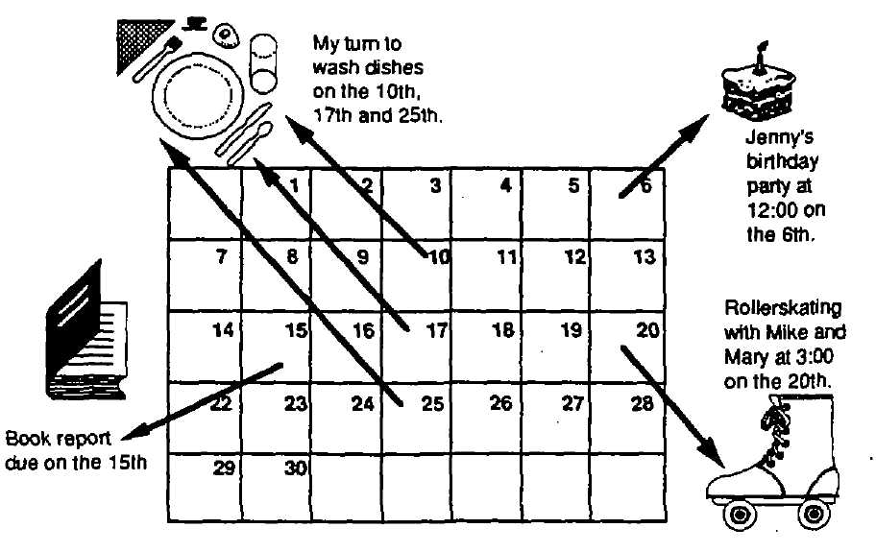

Bonus Fun:

Pick any date on the calendar. Subtract the number above it. Pick another date and subtract the number above it.

Do you notice a pattern?       Does it always work?       Why?

**Calendar Capers**

Each student needs to bring a current, printed calendar to class, or print calendar pages from the Internet.

For the month of \_\_\_\_\_\_\_\_\_\_ (teacher choice), can you answer the following questions?

1. How many days of the week have five dates during this month?

2. Matt's family plans to leave on vacation on the 16th and return the evening of the 26th. How many days of school will Matt miss?

3. Rusty’s dog, Barney, needs medicine for ten days to clear up an infection. He began treatment on the 13th. When will be the first dayhe doesn’t have to give his dog, Barney, medicine anymore?

4. The Science Club always meets the third Tuesday of the month after school. On what datewill they meet next month?

5. Wendy has a job baby-sitting after school on Tuesday and Thursday afternoons from 4:00 until 6:00. She gets $2.50 per hour for her work. How much money can she make this month?

6. On what day of the week does the month begin?

7. Roni's mom gets paid every Friday. How many paychecks will she get this month?

8. Craig has a dentist appointment the third Tuesday of the month. What date will he have his dentist appointment?

9. What is the difference between *day*and *date*on a calendar?

10. Tommy Thompson works Mondays and Fridays cleaning cages at the animal hospital. How many days will he work this month?

**Fun Comparing Measures**

**For each letter, check the choice that best answers the question.**

1. Which is hotter?2. Which is longer?

100 ° F or 82° C 1 yd. or 1 ft.

6° C or 40° F  20 in. or 46 in.

36° F or 19° C  20 yds. or 17 mi.

3. Which is larger? 4. Which is heavier?

1qt. or 1 pt.  3 lbs. or 30 oz.

10 gals, or 24 gals.  12 oz. or 40 oz.

18 pts. or 4 gals.  8 oz. or 3 lbs.

5. Which is taller? 6. Which is wider?

5 ft. 4 in. **or** 5 ft. 7 in.  1m. or 4 m.

2 ft. or 20 in.  4 in. or 4 ft.

72 in. or 6 ft. 3 in.  200 cm. or 3 m.

7. Which is later?8. Which is more?

Jan. 15 or Jan. 24  billions or hundreds

June 14 or Sept. 1  millions or tens

Jan. 4,1984 or Nov. 18,1983  thousands or ones

9. Which is quicker?10. Which is earlier?

10 seconds or 10 minutes  5 am. or 10 am.

1 hour or 1 day  3 p.m. or 6 p.m.

30 minutes or 1/4 hour  June 21 or Septembers

**Fun Comparing Measures**

11. Which is shorter?12. Which is fewer?

2 in. or 2 ft.  10 pieces or 1 dozen

20 yds. or 5 yds.  5 pounds or 8 ounces

10 ft. or 6 yds.  4 feet or 1 yard

**Rulers Tell the Truth**

**Place your ruler under each of these lines and record its length in the blank space provided.**

A. =       inches

B. =       inches

C. =       inches

D. =       inches

E. =       inches

F. =       inches

G. =       inches

H. =       inches

I. =       inches

J. =       inches

**Think Quickly**

Read the problems carefully. When you think you have the right answer, write it in. Then, reread the problem, and think about whether your answer makes sense.

1. If six inches were removed from a foot, then       inches would be left.

2. If 19 inches were removed from a yard, then       inches would be left.

3. If ten inches were removed from a foot, then       inches would be left.

4. If nine couples came to a party and seven people left, then       people would be left at the party.

5. If four eggs were removed from four dozen eggs, then       eggs would be left.

6. If nine ounces were removed from a pound, then       ounces would be left.

7. If you ask for a half-dozen donuts at Winchell’s, how many will you get?

8. There are 12 cows in the pasture. How many legs are there?       How many tails are there?

9. On the thermometer, do the high numbers indicate warm weather or cold weather?

10. Count to 40 by 4’s:   ,   ,   ,   ,   ,   ,   ,   ,   ,

11. Name three objects that come in pairs?      ,      ,

**How Much Time?**

1. How many minutes are between 10:30 and 11:00?

2. How long is it between 4:45 and 5:30?

3. What is the number of minutes between 10:00 and 11:30?

4. How long is it between 11:30 and 12:30 p.m.?

5. How many hours between 12:20 p.m. and 12:30 a.m.?

6. How much time goes by between 9:00 p.m. and 3:30 a.m.?

C:\Program Files\Microsoft Office\MEDIA\CAGCAT10\j0234131.wmf

**Pre-evaluation #1**

List as many occupations as you can in

two minutes!

Now go back over your list and highlight five occupations about which you would like to learn more.

|  |  |  |
| --- | --- | --- |
|  |  |  |
|  |  |  |
|  |  |  |
|  |  |  |
|  |  |  |
|  |  |  |
|  |  |  |
|  |  |  |

**Pre-evaluation #2**

1. What is the *key* to a successful career?

2. What have you learned at school that will help you most in your success on a job?

3. What tasks do your parents or guardians do in their jobs?

4. Have you ever talked with anybody about going to college?

5. Have you ever talked with anybody about the kind of work you will do?

6. Have you ever talked with anybody about your future?

7. Give three reasons why it is important to do well in school.

8. What will be *most* important to you when you get a job?

**Post-evaluation**

Now that you have completed a semester of CONNECTIONS, write all the areas about which you are interested in learning more. Try to think of at least 10.

|  |  |
| --- | --- |
| 1. |  |
| 2. |  |
| 3. |  |
| 4. |  |
| 5. |  |
| 6. |  |
| 7. |  |
| 8. |  |
| 9. |  |
| 10. |  |

Now, compare this list with your starred occupations from earlier in the year.

* Have you changed your mind on any?
* Added any?
* Still interested in some?

Keep up the good work! You're learning about yourself and the world of work. That's what's important!

**Pre/Post-evaluation #1**

Ask students to respond to the following questions:

1. Name 30 different careers.

2. What would you like to be?       Why?

Collect student responses. Examine and compare student responses before and after completion of the CONNECTIONS program with these questions in mind:

1. Were initial career choices and lists limited to careers of parents and those typical of your community?

2. Were some students unable to list 30 careers?

3. Were career lists narrow in range?

4. How many and what types of stereotypes were evident initially?

5. Has overall career awareness expanded?

6. What changes did you notice in the students’ ability to respond after completing the unit?

**Pre/Post-evaluation #2**

The teacher should ask students to define the following terms. Make one set of colored “term” cards and one set of colored “definition” cards. Ask students to match terms to definitions. This activity can be timed each time it is completed. Students are to beat their previous record.

Application Form: A form you fill out when you apply for a job

Career Goal: An idea of the kind of work you want to do

Employer: A person or company that hires you

Employment: An occupation or job

Entry Level Job: A first job, beginning job in a company

Interests: Activities or hobbies you enjoy

Interviewer: The employer or person asking an applicant questions

Interviewee: The employee or person answering questions

Job Clusters: A group of jobs that are similar

Job Resources: A way to find out about job openings

Occupation: The kind of work a person does

Personal Data Sheet: A form you fill out to give to an interviewer before you are interviewed

Personnel Office or

Employment Office: A place where you take an application and have an interview

Wage: Money paid by the hour or project or product for the work that you do

Want Ads: The section of the newspaper or online directory where job openings are listed

Work Values: The things you do that an employer thinks are important for you to be a good employee

Work Experience: Job training you get by working on the job

Work Skills: Things you can do without help

Yellow Pages: The name of the telephone or online directory where businesses are listed by name, address, and phone number

**Pre/Post-evaluation #3**

Teachers respond to the following:

|  |  |  |  |
| --- | --- | --- | --- |
|  | **Responsibility** | **Yes** | **No** |
| 1. | Dresses appropriately for different activities? |  |  |
| 2. | Arrives at the right place at the right time? |  |  |
| 3. | Finishes work assignments on time? |  |  |
| 4. | Works at a task until it is completed or until it is the appropriate time to stop? |  |  |
| 5. | Has a good attendance record? |  |  |
| 6. | Accepts responsibility for learning new skills in order to improve his or her work? |  |  |
| 7. | Can work without the help of others? |  |  |
| 8. | Obtains and arranges materials needed to perform a task? |  |  |
| 9. | Is willing to perform a task that must be done, even if it is difficult or unpleasant? |  |  |
| 10. | Adjusts well to new methods, plans and schedules? |  |  |
|  | **Total checks in each column** |  |  |
|  | **Personality** | **Yes** | **No** |
| 1. | Gets along with most people? |  |  |
| 2. | Has a good sense of humor? |  |  |
| 3. | Makes friends easily? |  |  |
| 4. | Identifies and accepts praise from others appropriately? |  |  |
| 5. | Considers how others may react before speaking? |  |  |
| 6. | Controls his/her temper? |  |  |
| 7. | Recognizes his/her weaknesses and attempts to correct or adjust to them? |  |  |
| 8. | Accepts criticism in an appropriate manner? |  |  |
| 9. | Is willing to try a new task or skills? |  |  |
|  | **Total checks in each column** |  |  |
|  | **Attitude** |  |  |
| 1. | Applies himself/herself when given a new task? |  |  |
| 2. | Is willing to help others? |  |  |
| 3. | Accepts responsibility for his or her actions? |  |  |
| 4. | Accepts criticism without pouting or getting angry? |  |  |
| 5. | Respects and is concerned about the rights and feelings of others? |  |  |
| 6. | Respects the value and need for rules? |  |  |
| 7. | Has initiative and ambition to achieve? |  |  |
| 8. | Is honest and trustworthy? |  |  |
| 9. | Has a cooperative attitude? |  |  |
| 10. | Is willing to share knowledge and materials in a group situation? |  |  |
|  | **Total checks in each column** |  |  |
|  |  |  |  |
|  | **TOTAL CHECKS IN EACH COLUMN** |  |  |

**Pre/Post-test**

Please answer the following questions:

1. What is an occupation?

2. Why are social skills important on a job?

3. When should you start working on the social skills you need on the job?

4. Is there an exact age to decide what you’ll be when you grow up?

5. How should you decide?

6. What skills or experiences do you have right now that will help you on your future job?

**Answer Key to Pre/Post-test**

1. What is an occupation?

*A person’s profession or job*

2. Why are social skills important on a job?

*Most jobs in the future will require that you work with other people on teams or in pairs. Few jobs will allow you to work without interacting with anyone. An employer is usually willing to train you and allow you time to learn a job if you are motivated and able to get along well with him and with others. However, an employer is not usually willing to take time with someone who does not get along with others, causes fights, and/or makes the workplace an unpleasant place.*

3. When should you start working on the social skills you need on the job?

*The sooner the better!!!*

4. Is there an exact age to decide what you’ll be when you grow up?

Absolutely not. People not only decide at all different ages how they will earn a living, but most people change their occupations three to five times in their lives.

5. How should you decide?

*Get information from as many places as possible (your parents, school, relatives, neighbors, counselors, friends), or volunteer, job shadow, and/or observe.*

6. What skills or experiences do you have right now that will help you on your future job?

*Are you dependable? Do you get along with others? Do you listen to directions? Do you know how to run some basic machines (computers, dishwashers, vacuums, calculators, etc.)? Can you work well with money? Are you on time? Are you well groomed?*

**Classroom and Job Readiness Skills Checklist**

|  |  |  |  |  |  |  |  |
| --- | --- | --- | --- | --- | --- | --- | --- |
| **Responsibility** | **X** | **Responsibility** | **X** | **Goal Setting** | **X** | **Interpersonal**  **Skills** | **X** |
| Listens |  | Uses an agenda |  | Sets Goals |  | Eye contact |  |
| Follows directions and rules |  | Respects others |  | Self-evaluates |  | Greets/responds |  |
| Completes Assignments |  | Self-starts |  | Works independently |  | Gives and accepts compliments |  |
| Seeks Help |  | Is cooperative |  | Takes responsibility |  | Disagrees appropriately |  |
| Maintains neat appearance |  | Is punctual |  |  |  | Uses manners |  |
| Works safely |  | Attends daily |  |  |  | Interview skills |  |
| Demonstrates honesty |  | Uses time productively |  |  |  | Offers help |  |
| Demonstrates pride in work |  | Plans work and meets deadlines |  |  |  | Shakes hands |  |
| Brings homework back |  |  |  |  |  | Introduces self and others |  |
|  |  |  |  |  |  |  |  |
| **Cooperative Learner** | **X** | **Using Learning Strategies** | **X** | **Using Tools and Equipment** | **X** |  |  |
| Works on a team |  | Knows learning style |  | Word processer |  |  |  |
| Printer |  |
| Contributes to discussion |  | Skips and comes back when stuck |  | PowerPoint |  |  |  |
| Excel |  |
| Self-corrects |  | Uses context for meaning |  | Search engine |  |  |  |
| Saves work |  |
| Accepts group’s attitude |  | Reads-on; Rereads |  | Retrieves work |  |  |  |
| Spell-checks work |  |
| Joins in |  | Reads key words |  | Tablet |  |  |  |
| Computer Calculator |  |
| Is flexible |  | Underlines key words |  | Measurement Tools: |  |  |  |
| \* Scale |  |
| Gives and accepts feedback |  | Skim/Scans |  | \* Compass |  |  |  |
| \* Tape Measure |  |
|  |  | Reads questions first |  |  |  |  |  |
|  |  |
|  |  | Proofreads work |  |  |  |  |  |

**Effective Education Checklist**

|  |  |  |  |  |  |
| --- | --- | --- | --- | --- | --- |
| **Deals with Feelings** | **X** | **Alternatives to Aggression** | **X** | **Dealing with Stress** | **X** |
| Knows own feelings |  | Uses self-control |  | Deals with boredom |  |
| Expresses feelings |  | Asks permission |  | Identifies the problem |  |
| Recognizes other feelings |  | Responds to teasing appropriately |  | Complains appropriately |  |
| Shows understanding of others’ feelings |  | Avoids trouble |  | Responds to a complaint appropriately |  |
| Expresses concern for another |  | Accepts responsibility for own behavior |  | Demonstrates appropriate sportsmanship |  |
| Deals with anger |  | Deals with an accusation appropriately |  | Deals appropriately with being left out or embarrassed |  |
| Expresses affection |  | Negotiates respectfully |  | Reacts to failure appropriately |  |
| Deals with anxiety |  | Accepts “no” |  | Relaxes |  |
| Rewards self |  |  |  | Deals with group pressure |  |
|  |  |  |  | Is honest |  |
|  |  |  |  | Makes a decision |  |

**Functional Consumer Academics:**

**Connections between Home, School, and Community**

|  |  |  |  |  |  |
| --- | --- | --- | --- | --- | --- |
| **Functional Math** | **X** | **Functional Reading** | **X** | **Functional Writing** | **X** |
| Calculates hours/pay |  | Reads and comprehends menus |  | Completes applications |  |
| Counts money |  | Reads and comprehends newspapers and ads |  | Completes checks, register, and deposit slips |  |
| Budgets money |  | Reads and comprehends graphs |  | Addresses envelopes |  |
| Estimates total purchase price |  | Reads and comprehends charts |  | Writes thank you notes |  |
| Estimates tax and tip |  | Reads and comprehends maps |  | Writes e-mail, memos, and notes |  |
| Completes check and deposit slip |  | Reads and comprehends directions |  | Writes directions |  |
| Records in register |  | Reads and comprehends recipes |  | Writes interview notes |  |
| Calculates register |  | Reads and comprehends community signs |  | Completes time card |  |
| Demonstrates knowledge of parts of paycheck |  | Reads and comprehends schedules |  | Writes for personal use and pleasure |  |
| Endorses paycheck |  |  |  | Writes reports |  |
| Measures by cups and spoons |  |  |  | Writes expository text (descriptive, cause-effect, problem-solution) |  |
| Uses calculator |  |  |  |  |  |
| Estimates for all purposes |  |  |  |  |  |

**Goal-Setting Worksheet**

Choose three to five of the following goals for yourself. Also choose two or three objectives for each goal that explain how you intend to reach your goal. These specific skills correlate directly with the job skills employers’ request.

**Goal 1: To improve my ability to control my impulses by:**

|  |  |  |
| --- | --- | --- |
| **X** |  |  |
|  | A. | Raising my hand; not interrupting in class |
|  | B. | Thinking before I talk |
|  | C. | Sticking to the topic during discussions |
|  | D. | Staying on task for 30 minutes during group or private study |
|  | E. | Stopping myself from making inappropriate noises |
|  | F. | Predicting the consequences of my actions |
|  | G. | Other: |

**Goal 2: To become more responsible for myself by:**

|  |  |  |
| --- | --- | --- |
| **X** |  |  |
|  | A. | Completing assignments |
|  | B. | Completing chores around the house and in the classroom |
|  | C. | Arriving on time to classes with materials |
|  | D. | Asking for assistance when I need it |
|  | E. | Relying on myself whenever possible |
|  | F. | Admitting my part in a mistake rather than blaming |
|  | G. | Remaining calm and patient while waiting for assistance |
|  | H. | Resolving disagreements by talking them out |
|  | I. | Making request, compromises, or verbal agreements |
|  | J. | Other: |

**Goal-Setting Worksheet**

**Goal 3: To improve my ability to communicate well by:**

|  |  |  |
| --- | --- | --- |
| **X** |  |  |
|  | A. | Listening carefully to other; not interrupting |
|  | B. | Making short, clear requests of people and not just complaining |
|  | C. | Responding to questions with clear, direct, honest remarks |
|  | D. | Using language appropriate to the situation |
|  | E. | Sharing ideas, opinion, and feelings in group discussions |
|  | F. | Stopping myself from using verbal put-downs or harassment |
|  | G. | Recognizing and sharing feelings when appropriate |
|  | H. | Telling others exactly what I think I need |
|  | I. | Letting others know I understand what they think and how they feel through verbal feedback |
|  | J. | Opening conversations appropriately with others |
|  | K. | Other: |

**Goal 4: To improve my ability to get along with others by:**

|  |  |  |
| --- | --- | --- |
| **X** |  |  |
|  | A. | Recognizing and acknowledging the rights of others |
|  | B. | Showing understanding of and respect for others’ opinions |
|  | C. | Inviting others to do things with me |
|  | D. | Working cooperatively on assignments or projects with others |
|  | E. | Communicating my needs to others in appropriate ways |
|  | F. | Stopping myself from using verbal put-downs or harassment |
|  | G. | Refraining from fighting with others |
|  | H. | Other: |

**Goal-Setting Worksheet**

**Goal 5: To improve my opinion of myself by:**

|  |  |  |
| --- | --- | --- |
| **X** |  |  |
|  | A. | Taking positive risks; doing worthwhile activities I usually avoid |
|  | B. | Acknowledging myself when I do a good job |
|  | C. | Comparing myself and my own successes—not to others, but to previous attempts of my own |
|  | D. | Recognizing qualities about me that make me likable and valuable to others |
|  | E. | Being myself; letting others know my true feelings, thoughts, opinions, and values |
|  | F. | Accomplishing tasks requiring self-discipline |
|  | G. | Developing a clearer sense of my own true values, opinions, and feelings |
|  | H. | Other: |

**Goal 6: To improve my ability to solve my own problems by:**

|  |  |  |
| --- | --- | --- |
| **X** |  |  |
|  | A. | Learning a problem solving system |
|  | B. | Learning to wait for my feelings to calm down before taking action or deciding on a solution |
|  | C. | Asking for advice or information before acting to solve difficult problems |
|  | D. | Taking steps to become independent in all areas like getting up in the morning, recording school assignments, getting chores done, attending to personal hygiene, etc. |
|  | E. | Other: |

**Goal-Setting Worksheet**

**Goal 7: To increase my ability to succeed in school by:**

|  |  |  |
| --- | --- | --- |
| **X** |  |  |
|  | A. | Organizing and recording school work and projects |
|  | B. | Asking questions as needed |
|  | C. | Staying for extra help |
|  | D. | Asking my friends to help as needed |
|  | E. | Completing assignments even when I don’t feel like it |
|  | F. | Turning in assignments even if they aren’t perfect |
|  | G. | Other: |

**Pre/Post-evaluation of IEP Goals and Objectives**

Directions: Please indicate (yes/no) on the following items.

**Responsible Behaviors at Work and School:**

|  |  |  |
| --- | --- | --- |
| **Student Can:** | **Yes** | **No** |
| Work independently until he/she completes the task? |  |  |
| Work at an acceptable rate? |  |  |
| Produce accurate work? |  |  |
| Take pride in own work? |  |  |
| Change behavior after criticism? |  |  |
| Ask for help when he/she doesn’t understand work? |  |  |
| Work for sense of accomplishment? |  |  |
| Adapt to changes in work routine? |  |  |
| Follow directions concerning job? |  |  |
| Learn new tasks through demonstrations? |  |  |
| Understand danger signals? |  |  |
| Observe work regulations? |  |  |
| Understand why it is important to be responsible at work? |  |  |
| Identify why people work? |  |  |
| Identify what he/she likes to do? |  |  |
| Show respect for property of others? |  |  |
| Comply with instructions in a timely manner? |  |  |
| Respond appropriately to constructive criticism?  **Student Can:** | **Yes** | **No** |
| Be responsible for own behavior? |  |  |
| Adhere to rules at school/work? |  |  |
| Remain in chair or at workstation during designated periods? |  |  |
| Refrain from engaging in disruptive behavior? |  |  |
| Interact appropriately with students and adults in the community? |  |  |
| Demonstrate helping behaviors? |  |  |
| Return to work promptly after breaks or recess? |  |  |
| Transfer learning to new setting? |  |  |

**Independence and Self-Help Skills**

|  |  |  |
| --- | --- | --- |
| **Student Can:** | **Yes** | **No** |
| Take care of himself/herself? |  |  |
| Make decisions independently? |  |  |
| Follow time schedules and instructions to go from place to place? |  |  |
| Know what to do in case of emergency? |  |  |
| Interact acceptably with people of the same gender and different gender? |  |  |
| Exhibit acceptable assertive behavior? |  |  |
| Demonstrate good grooming habits for school and work? |  |  |
| Dress appropriately for school and work? |  |  |
| Know what to do if lost? |  |  |

Hartley, Horiuchi, Mtthaug, Paulson, Glandt (1984)