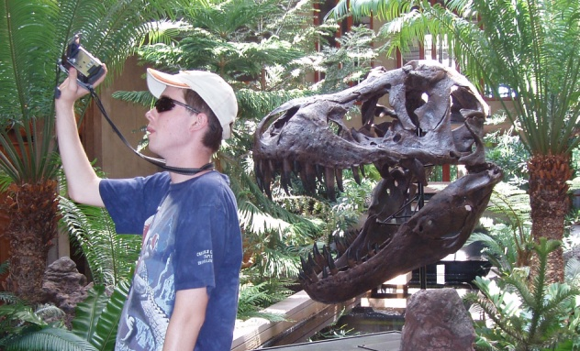MCAN03952_0000[1]

***Good support for me:***

Help me learn how to make my own movies.

Help me know how to understand other people.

Help me learn how to tell and keep track of time.

Give me encouragement and tell me when I’m doing something well.

Give me time to cool off when I’m upset.

Giving me a ride when I want to go somewhere.

Helping me count money when I need to buy something.

Helping me to know what to say on the phone and how to ask for help in a store or other place.

***What is important to me:***

Having time to be alone just to have peace and quiet.

Time spent on my computer, to research and surf the net.

My collections.

Having my books with me.

Doing things well and not making mistakes.

I would like to spend more time with friends, but it is very difficult to know how to invite people to do things.

My future goals of being a filmmaker and teacher.

***What people like and admire about me:***

I am nice and care about people.

I like to be responsible and help people.

I like to laugh and sometimes say funny things.

I am artistic.

I write stories and illustrate books that people like to look at.

I am helpful.

I know about a lot of things and can tell people facts they would like to know about animals, dinosaurs, and mythology.

I have a very good imagination.